
Programming Guide
EN01A
SDG Series
Arbitrary Waveform Generator
Content
1 Programming Overview 5
1.1 Build communication via VISA 5
1.1.1 Install NI-VISA 5
1.1.2 Connect the instrument 8
1.2 Remote Control 9
1.2.1 User-defined Programming 9
1.2.2 Using SCPI via NI-MAX 9
1.2.3 Using SCPI over Telnet 9
1.2.4 Using SCPI over Socket 10
2 Introduction to the SCPI Language 11
2.1 About Commands & Queries 11
2.2 Description 11
2.3 Usage 11
2.4 Command Notation 11
2.5 Table of Command & Queries 12
3 Commands and Queries 14
3.1 IEEE 488.2 Common Command Introduction 14
3.1.1 *IDN 14
3.1.2 *OPC 15
3.1.3 *RST 15
3.2 Output Command 16
3.3 Basic Wave Command 18
3.4 Harmonic Command 21
3.5 MultPulse Command 22
3.6 Arbitrary Wave Command 24
3.6.1 Sampling Rate Command 24
3.6.2 Arbitrary Wave Switch Command 24
3.6.3 Arb Data Command 28
3.7 Modulate Wave Command 29
3.8 Sweep Wave Command 33
3.8.1 <channel>: SweepWaVe <para>,<value> 33
3.8.2 <channel>:SWEep:TYPE <type> 35
3.8.3 <channel>:SWEep:SAMPlitude <value> 35
3.8.4 <channel>:SWEep:EAMPlitude <value> 36
3.8.5 <channel>:SWEep:CAMPlitude <value> 36
3.8.6 <channel>:SWEep:ASPan <value> 37
3.9 Burst Wave Command 38
3.10 Sequence Command 41
3.10.1 <channel>:SEQuence <switch> 41
3.10.2 <channel>:SEQuence:SRATe 41
3.10.3 <channel>:SEQuence:STATe 42
3.10.4 <channel>:SEQuence:SCALe 42
3.10.5 <channel>:SEQuence:OFFset 43
3.10.6 <channel>:SEQuence:SAVe 43
3.10.7 <channel>:SEQuence:RECall 43
3.10.8 <channel>:SEQuence:RMODe <mode> 44
3.10.9 <channel>:SEQuence:STARTNumb 44
3.10.10 <channel>:SEQuence:INTPo 45
3.10.11 <channel>: SEQuence:TRIGger:SOURce 45
3.10.12 <channel>:SEQuence:TRIGger:SLOPe 46
3.10.13 <channel>:SEQuence:TRIGger:TRIG 46
3.10.14 <channel>:SEQuence:TRIGger:HOLD 46
3.10.15 <channel>:SEQuence:TRIGger:Delay 47
3.10.16 <channel>:SEQuence:TRIGger:Out 47
3.10.17 <channel>:SEQuence:INCReasing 48
3.10.18 <channel>:SEQuence:DECReasing 48
3.10.19 <channel>:SEQuence:SEGMent:Add 49
3.10.20 <channel>:SEQuence:SEGMent<x>:INSErt 49
3.10.21 <channel>:SEQuence:SEGMent<x>:DELEte 49
3.10.22 <channel>:SEQuence:SEGMent:Clear 50
3.10.23 <channel>:SEQuence:SEGMent<x>:GOTO 50
3.10.24 <channel>:SEQuence:SEGMent<x>:LENGth 50
3.10.25 <channel>:SEQuence:SEGMent<x>:REPeat:COUNt 51
3.10.26 <channel>:SEQuence:SEGMent<x>:WAVeform 51
3.10.27 <channel>:SEQuence:SEGMent<x>:AMPlitude 52
3.10.28 <channel>:SEQuence:SEGMent<x>:OFFset 53
3.10.29 <channel>:SEQuence:SEGMent<x>:VOLTage:HIGH 53
3.10.30 <channel>:SEQuence:SEGMent<x>:VOLTage: LOW 54
3.11 Channel Track/Coupling Command 55
3.12 Channel Copy Command 56
3.13 Invert Command 56
3.14 Equal Phase Command 57
3.15 Waveform Combining Command 57
3.16 Power-On State command 57
3.17 Sync Command 58
3.18 Clock Source Command 58
3.19 Phase Mode Command 59
3.20 Freq_Com State Command 59
3.21 PowerOn Setting Command 59
3.22 Multi-Device Sync 60
3.23 Number Format Command 61
3.24 Language Command 61
3.25 Buzzer Command 62
3.26 Screen Saver Command 62
3.27 Frequency Counter Command 62
3.28 Over-Voltage Protection Command 64
3.29 Store List Command 64
3.30 Virtual Key Command 66
3.31 IP Command 68
3.32 Subnet Mask Command 68
3.33 Gateway Command 69
3.34 Gpib Command 69
3.35 File Operation Commands 70
3.35.1 MMEMory:DELete 70
3.35.2 MMEMory:RDIRectory 70
3.35.3 MMEMory:MDIRectory 70
3.35.4 MMEMory:CATalog 70
3.35.5 MMEMory:COPY 71
3.35.6 MMEMory:MOVE 71
3.35.7 MMEMory:SAVE:XML 72
3.35.8 MMEMory:LOAD:XML 72
3.35.9 MMEMory:TRANsfer 73
4 Waveform format 74
4.1 bin 74
4.2 csv/dat 75
4.3 mat 77
5 Programming Examples 79
5.1 Examples of Using VISA 79
5.1.1 VC++ Example 79
5.1.2 VB Example 85
5.1.3 MATLAB Example 89
5.1.4 LabVIEW Example 91
5.1.5 Python2 Example 94
5.1.6 Python3 Example 96
5.1.7 Python3 Example (Digital) 98
5.2 Examples of Using Sockets 100
5.2.1 Python Example 100
6 Index 103

Programming Overview
By using USB and LAN interfaces, in combination with NI-VISA and programming languages, users can remotely control the waveform generator. Through the LAN interface, VXI-11, Sockets, and Telnet protocols can be used to communicate with the instruments. This chapter introduces how to build communication between the instrument and the PC. It also introduces how to configure a system for remote instrument control.

Build communication via VISA

Install NI-VISA
Before programming, please make sure that you have properly installed the latest version of National Instruments NI-VISA Software.
NI-VISA is a communication library that enables computer communications to instrumentation. There are two available VISA packages: A full version and the Run-Time Engine. The full version includes NI device drivers and a tool named NI MAX; a user interface to control the device. While the drivers and NI MAX can be useful, they are not required for remote control. The Run-Time Engine is a much smaller file and is recommanded for remote control.
For convenience, you can obtain the latest version of the NI-VISA run-time engine or the full version from the National Instruments website. The installation process is similar for both versions.

Follow these steps to install NI-VISA (The full version of NI-VISA 5.4 is used in this example):

- Download the appropriate version of NI-VISA (the Run-time engine is recommanded)
- Double click the visa540_full.exe and observe the dialog box as shown below:


- Click Unzip, the install process will launch after unzipping files. If your computer needs to install the .NET Framework 4, it may auto-start.

- The NI-VISA install dialog is shown above. Click Next to start the installation process.

- Set the install path, the default path is “C:\Program Files\National Instruments\”, you can change it if you prefer. Click Next, dialog as shown above.

- Click Next twice, in the License Agreement dialog, select the “I accept the above 2 License Agreement(s).”, and click Next, and a dialog box will appear as shown below:

- Click Next to begin installation.

- Now the installation is complete. Reboot your PC.

Connect the instrument
Depending on the specific model, the arbitrary waveform generator may be able to communicate with a PC through the USB or LAN interface.

Connect the arbitrary waveform generator and the USB Host interface of the PC using a USB cable. Assuming your PC is already turned on, turn on the SDG, and then the PC will display the “Device Setup” screen as it automatically installs the device driver as shown below.

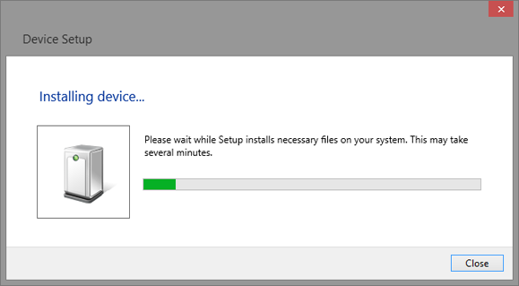

Wait for the installation to complete and then proceed to the next step.

Remote Control

User-defined Programming
Users can send SCPI commands via a computer to program and control the arbitrary waveform generator. For details, refer to the introductions in "Programming Examples Programming Examples".

Using SCPI via NI-MAX
NI-MAX is a program created and maintained by National Instruments. It provides a basic remote control interface for VXI, LAN, USB, GPIB, and Serial communications. The SDG can be controlled remotely by sending SCPI commands via NI-MAX.

Using SCPI over Telnet
Telnet provides a means of communicating with the SDG over the LAN. The Telnet protocol sends SCPI commands to the SDG from a PC and is similar to communicating with the SDG over USB. It sends and receives information interactively: one command at a time. The Windows operating systems use a command prompt style interface for the Telnet client. The steps are as follows:
- On your PC, click Start > All Programs > Accessories > Command Prompt.
- At the command prompt, type in telnet.
- Press the Enter key. The Telnet display screen will be displayed.

- At the Telnet command line, type:open XXX.XXX.XXX.XXX 5024
Where XXX.XXX.XXX.XXX is the instrument’s IP address and 5024 is the port. You should see a response similar to the following:
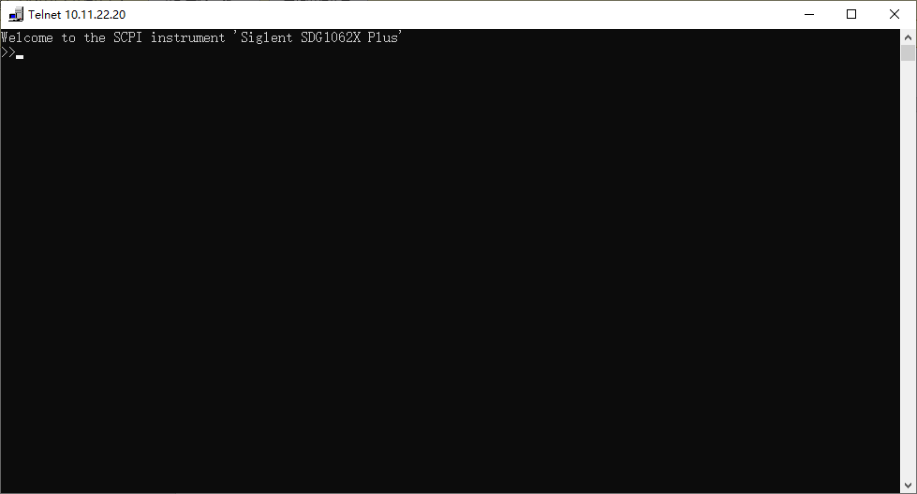

- At the SCPI> prompt, input the SCPI commands such as *IDN? to return the company name, model number, serial number, and firmware version number.
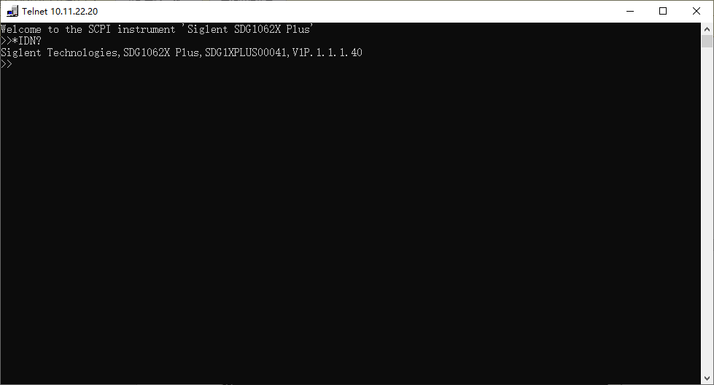

- To exit the SCPI> session, press the Ctrl+] keys simultaneously.
- Type quit at the prompt or close the Telnet window to close the connection to the instrument and exit Telnet.

Using SCPI over Socket
Socket API can be used to control the SDG series by LAN without installing any other libraries. This can reduce the complexity of programming.
SOCKET ADDRESS | IP address + port number
IP ADDRESS | SDG IP address
PORT NUMBER | 5025

Please see section 5.2 "Examples of Using Sockets" for the details.

Introduction to the SCPI Language

About Commands & Queries
This section lists and describes the remote control commands and queries recognized by the instrument. All commands and queries can be executed in either the local or remote state.

Each command or query, with syntax and other information, has some examples listed. The commands are given in both long and short format at “COMMAND SYNTAX” and “QUERY SYNTAX”, and the subject is indicated as a command or query or both. Queries perform actions such as obtaining information from the instrument and are identified by a question mark (?) following the header.

Description
In the description, a brief explanation of the function performed is given. This is followed by a presentation of the formal syntax, with the header given in Upper-and-Lower-Case characters and the short form derived from it in ALL UPPER-CASE characters. Where applicable, the syntax of the query is given with the format of its response.

Usage
The commands and queries listed here can be used for SDGxxxx Series Arbitrary Waveform Generators.

Command Notation
The following notations are used in the commands:
< > Angular brackets enclose words that are used as placeholders, of which there are two types: the header path and the data parameter of a command.
:= A colon followed by an equals sign separates a placeholder, from the description of the type and range of values that may be used in a command instead of the placeholder.
{ } Braces enclose a list of choices, one of which must be made.
[ ] Square brackets enclose optional items.
… ] Ellipsis (trailing dots) indicate that the preceding element may be repeated one or more times.

Table of Command & Queries
Short | Long Form | Subsystem | What Command/Query does
*IDN | *IDN | SYSTEM | Gets identification from device.
*OPC | *OPC | SYSTEM | Gets or sets the OPC bit (0) in the Event Status Register (ESR).
*RST | *RST | SYSTEM | Restore default settings
CHDR | COMM_HEADER | SIGNAL | Sets or gets the command returned format
OUTP | OUTPUT | SIGNAL | Sets or gets the output state.
BSWV | BASIC_WAVE | SIGNAL | Sets or gets the basic wave parameters.
MDWV | MODULATEWAVE | SIGNAL | Sets or gets the modulation parameters.
SWWV | SWEEPWAVE | SIGNAL | Sets or gets the sweep parameters.
BTWV | BURSTWAVE | SIGNAL | Sets or gets the burst parameters.
PACP | PARACOPY | SIGNAL | Copies parameters from one channel to the other.
ARWV | ARBWAVE | DATA | Changes arbitrary wave type.
SYNC | SYNC | SIGNAL | Sets or gets the synchronization signal.
NBFM | NUMBER_FORMAT | SYSTEM | Sets or gets the data format.
LAGG | LANGUAGE | SYSTEM | Sets or gets the language.
SCFG | SYS_CFG | SYSTEM | Sets or gets the power-on system setting way.
BUZZ | BUZZER | SYSTEM | Sets or gets the buzzer state.
SCSV | SCREEN_SAVE | SYSTEM | Sets or gets the screen save state.
ROSC | ROSCILLATOR | SIGNAL | Sets or gets the state of the clock source.
FCNT | FREQCOUNTER | SIGNAL | Sets or gets the frequency counter parameters.
INVT | INVERT | SIGNAL | Sets or gets the polarity of the current channel.
COUP | COUPLING | SIGNAL | Sets or gets the coupling parameters.
VOLTPRT | VOLTPRT | SYSTEM | Sets or gets the state of over-voltage protection.
STL | STORELIST | SIGNAL | Lists all stored waveforms.
WVDT | WVDT | SIGNAL | Sets and gets the arbitrary wave data.
VKEY | VIRTUALKEY | SYSTEM | Sets the virtual keys.
SYST:COMM:LAN:  IPAD | SYSTEM:COMMUNICATE:LAN:IPADDRESS | SYSTEM | The Command can set and get the system IP address.
SYST:COMM:LAN:SMAS | SYSTEM:COMMUNICATE:LAN:SMASK | SYSTEM | The Command can set and get the system subnet mask.
SYST:COMM:LAN:GAT | SYSTEM:COMMUNICATE:LAN:GATEWAY | SYSTEM | The Command can set and get the system Gateway.
SRATE | SAMPLERATE | SIGNAL | Sets or gets the arbitrary wave mode, sampling rate, and interpolation method.
HARM | HARMonic | SIGNAL | Sets or gets the harmonic information.
CMBN | CoMBiNe | SIGNAL | Sets or gets the wave combine information.
MODE | MODE | SIGNAL | Sets or gets the waveform phase mode
CASCADE | CASCADE | SYSTEM | Set up multi-device synchronization

Commands and Queries

IEEE 488.2 Common Command Introduction
The IEEE standard defines the common commands used for querying the basic information of the instrument or executing basic operations. These commands usually start with "*" and the length of the keywords of the command is usually 3 characters.

*IDN
DESCRIPTION | The *IDN? query causes the instrument to identify itself.  The response is comprised of the manufacturer, model, serial number, and firmware version.
QUERY SYNTAX | *IDN?
RESPONSE FORMAT | Format 1: *IDN, <device id>,<model>,<serial number>,<firmware version>, <hardware version>  Format 2: <manufacturer>,<model>,<serial number>,<firmware version>  <device id>:= “SDG”.  <manufacturer>:= “Siglent Technologies”.  <model>:= A model identifier less than 14 characters, should not contain the word “MODEL”.  <serial number>:= The serial number.  <firmware version>:= The firmware version number.  <hardware version>:= The hardware level field, containing information about all separately revisable subsystems.
EXAMPLE | Reads version information:  *IDN?  Return:  Siglent Technologies,SDG1062X Plus,SDG1XPLUS00041,  V1P.1.1.1.40 (It may differ from each version)

Notes:
- Format of <hardware version>: value1-value2-value3-value4-value5.
value1: PCB version.
value2: Hardware version.
value3: Hardware subversion.
value4: FPGA version.
value5: CPLD version.

*OPC
DESCRIPTION | The *OPC (Operation Complete) command sets the OPC bit (bit 0) in the standard Event Status Register (ESR). This command has no other effect on the operation of the device because the instrument starts parsing a command or query only after it has completely processed the previous command or query. The *OPC? query always responds with the ASCII character 1 because the device only responds to the query when the previous command has been entirely executed.
COMMAND SYNTAX | *OPC
QUERY SYNTAX | *OPC?
RESPONSE FORMAT | 1

*RST
DESCRIPTION | The *RST command initiates a device reset and recalls the default setup.
COMMAND SYNTAX | *RST
EXAMPLE | This example resets the signal generator to the default setup:  *RST

Output Command
DESCRIPTION | This command enables or disables the output port(s) at the front panel. The query returns “ON” or “OFF” and “LOAD”, “PLRT”, and “RATIO” parameters.
COMMAND SYNTAX | <channel>:OUTPut ON|OFF,LOAD,<load>,PLRT, <polarity>  <channel>:= {C1, C2}.  <load>:= {see the note below}. The unit is ohms.  <polarity>:= {NOR, INVT}, in which NOR refers to normal, and INVT refers to invert.  NoiseSum: to add noise to the channel with specified signal-to-noise ratio.  <channel>:NOISE_ADD STATE,ON|OFF,RATIO,<S/N>.  or  <channel>:NOISE_ADD STATE,ON|OFF,RATIO_DB,<S/N(dB)>.  <S/N>:= {2.1-100000000}.  <S/N (dB)>:= {3.24886-80}.  Max Amplitude Output: to limit the maximum amplitude output.  <channel>:BSWV MAX_OUTPUT_AMP, <Amplitude>  <Amplitude>:={1-20}, Maximum output amplitude peak-to-peak voltages.
QUERY SYNTAX | <channel>:OUTPut?  <channel>:NOISE_ADD?  <channel>:BSWV?
RESPONSE FORMAT | <channel>:OUTP ON|OFF,LOAD,<load>,PLRT, <polarity>  <channel>:NOISE_ADDSTATE,ON|OFF,RATIO,<S/N >,  RATIO_DB,<S/N (dB)>  <channel>:BSWV WVTP,<type>,FRQ,<frequency>,PERI,<period>,AMP,<amplitude>,AMPVRMS,<Amplitude>,MAX_OUTPUT_AMP, OFST, <offset>, HLEV, <high level>, LLEV, <low level>, PHSE, <phase>
EXAMPLE | Turn on CH1:  C1:OUTP ON  Read CH1 output state:  C1:OUTP?  Return:  C1:OUTP ON,LOAD,HZ,PLRT,NOR  Set the load of CH1 to 50 ohms:  C1:OUTP LOAD,50  Set the load of CH1 to HiZ:  C1:OUTP LOAD,HZ  Set the polarity of CH1 to normal:  C1:OUTP PLRT,NOR  turn on NoiseSum and set the signal-to-noise ratio  C1:NOISE_ADD STATE,ON,RATIO,120  Set the maximum output amplitude  C1:BSWV MAX_OUTPUT_AMP,5
Note: * "HiZ" refers to High Z.

DESCRIPTION | Set two channels to open or close output at the same time
COMMAND SYNTAX | OUT_BOTHCH <STATE>  <STATE>={ON,OFF}
QUERY SYNTAX
RESPONSE FORMAT
EXAMPLE | Open two channels of output:  OUT_BOTHCH ON

Basic Wave Command
DESCRIPTION | This command sets or gets the basic wave parameters.
COMMAND SYNTAX | <channel>:BaSic_WaVe <parameter>,<value>  <channel>:={C1, C2}.  <parameter>:= {a parameter from the table below}.  <value>:={value of the corresponding parameter}.
Parameters | Value | Description
WVTP | <type> | := {SINE, SQUARE, RAMP, PULSE, NOISE, ARB, DC, PRBS, MULTPULSE ,SEQUENCE}. If the command doesn’t set basic waveform type, WVPT will be set to the current waveform.
FRQ | <frequency> | := frequency. The unit is Hertz “Hz”. Refer to the datasheet for the range of valid values. Not valid when WVTP is NOISE or DC.
PERI | <period> | := period. The unit is seconds "s". Refer to the datasheet for the range of valid values. Not valid when WVTP is NOISE or DC.
AMP | <amplitude> | := amplitude. The unit is volts, peak-to-peak "Vpp". Refer to the datasheet for the range of valid values. Not valid when WVTP is NOISE or DC.
AMPVRMS | <amplitude> | := amplitude. The unit is Volts, root-mean-square “Vrms”.
AMPDBM | <amplitude> | := amplitude. The unit is dBm.
OFST | <offset> | := offset. The unit is volts "V". Refer to the datasheet for the range of valid values. Not valid when WVTP is NOISE.
COM_OFST | <common offset> | :={-1 to 1}.common offset. The unit is volts "V". It can be set only when the channel differential output is on.
SYM | <symmetry> | :={0 to 100}. Symmetry of RAMP. The unit is "%". Only settable when WVTP is RAMP.
DUTY | <duty> | := {0 to 100}. Duty cycle. The unit is "%". Value depends on frequency. Only settable when WVTP is SQUARE or PULSE.
PHSE | <phase> | := {0 to 360}. The unit is "degree". Not valid when WVTP is NOISE, PULSE or DC.
STDEV | <stdev> | := standard deviation of NOISE. The unit is volts "V". Refer to the datasheet for the range of valid values. Only settable when WVTP is NOISE.
MEAN | <mean> | := mean of NOISE. The unit is volts "V". Refer to the datasheet for the range of valid values. Only settable when WVTP is NOISE.
WIDTH | <width> | := positive pulse width. The unit is seconds "s". Refer to the datasheet for the range of valid values. Only settable when WVTP is PULSE.
RISE | <rise> | := rise time (10%~90%). The unit is seconds "s". Refer to the datasheet for the range of valid values. Only settable when WVTP is PULSE.
FALL | <fall> | := fall time (90%~10%). The unit is seconds "s". Refer to the datasheet for the range of valid values. Only settable when WVTP is PULSE.
DLY | <delay> | := waveform delay. The unit is seconds "s". Refer to the datasheet for the range of valid values.
HLEV | <high level> | := high level. The unit is volts "V". Not valid when WVTP is NOISE or DC.
LLEV | <low level> | := low level. The unit is volts "V". Not valid when WVTP is NOISE or DC.
BANDSTATE | <bandwidth switch > | := {ON,OFF}. Only settable when WVTP is NOISE.
BANDWIDTH | <bandwidth value> | := noise bandwidth. The unit is Hertz "Hz". Refer to the datasheet for the range of valid values. Only settable when WVTP is NOISE.
LENGTH | <prbs length> | :={3~32}. Actual PRBS length = 2^{LENGTH}-1. Only settable when WVTP is PRBS.
EDGE | <prbs rise/fall> | := rise/fall time of PRBS. The unit is seconds "s". Refer to the datasheet for the range of valid values. Only settable when WVTP is PRBS.
FORMAT | <output format> | :={DIFF, SINGLE }. Set channel differential output or single ended output
DIFFSTATE | <prbs differential switch> | :={ON, OFF}. State of PRBS differential mode. Only settable when WVTP is PRBS.
BITRATE | <prbs bit rate> | := PRBS bit rate. The unit is bits-per-second "bps". Refer to the datasheet for the range of valid values. Only settable when WVTP is PRBS.
LOGICLEVEL | <prbs logiclevel rate> | :={ TTL_CMOS, LVTTL_LVCMOS, ECL, LVPECL, LVDS CUSTOM }. Only settable when WVTP is PRBS.
MAX_OUTPUT_AMP | <amplitude> | :=Channel maximum amplitude limit. Refer to the datasheet for the range of valid values.

QUERY SYNTAX | <channel>: BaSic_WaVe?  <channel>:= {C1, C2}.
RESPONSE FORMAT | <channel>:BSWV <parameter>  <parameter>:= {All the parameters of the current basic waveform}.
EXAMPLE | Change the waveform type of C1 to Ramp:  C1:BSWV WVTP,RAMP  Change the frequency of C1 to 2000 Hz:  C1:BSWV FRQ,2000  Set the amplitude of C1 to 3 Vpp:  C1:BSWV AMP,3  Return parameters of C1 from the device:  C1:BSWV?  Return:  C1:BSWV WVTP,SINE,FRQ,100HZ,PERI,0.01S,AMP,2V,  OFST,0V,HLEV,1V,LLEV,-1V,PHSE,0  Set noise bandwidth of C1 to 100 MHz:  C1:BSWV BANDWIDTH,100E6  or  C1:BSWV BANDWIDTH,100000000  Set output amplitude of C1 to 3dBm:  C1:BSWV AMPDBM,3  Set the logic level of C1 to TTL_CMOS:  C1:BSWV LOGICLEVEL,TTL_CMOS

Harmonic Command
DESCRIPTION | This command sets or gets the harmonic parameters. Only available when the basic wave is SINE.
COMMAND SYNTAX | < channel >:HARMonic < parameter >,< value >  < channel >:= {C1, C2}.  < value >:= { The values of relevant parameters }
parameter | value | Description
HARMSTATE | <STATE> | :={ON, OFF} Turn harmonics on or off
HARMTYPE | <TYPE> | : {EVEN , ODD , ALL} harmonic types.
HARMORDER | <NUM> | : {1, 2,..., M}, where M is the maximum supported series.
HARMPHASE | <PHASE> | := {0~360}, the unit is "degree"
HARMAMP | <VALUE> | := amplitude of specified harmonic. the unit is "dBc".
HARMDBC | <VALUE> | := amplitude of specified harmonic. the unit is "dBc".

QUERY SYNTAX | < channel >:HARMonic?  < channel >:={C1, C2}.
EXAMPLES | Enable the harmonic function of CH1:  C1:HARM HARMSTATE,ON  Set the 2nd harmonic of CH1 to -6 dBc:  C1:HARM HARMORDER,2,HARMDBC,-6  Get the harmonic information of CH1:  C1:HARM?  Return: C1:HARM ,HARMSTATE,ON,HARMTYPE,EVEN,HARMORDER,2,HARMAMP,2.004748935V,HARMDBC,-6dBc,HARMPHASE,0

MultPulse Command
DESCRIPTION | This command sets or gets the multpulse parameters. Only available when the basic wave is multpulse.
COMMAND SYNTAX | Format1:  < channel >:MultiPulse < parameter1 >,< value >  < channel >:={C1, C2}.  < value >:= {The values of relevant parameters1 }  Format2:  < channel >:MultiPulse:Item<index>:< parameter2 >,< value >  < channel >:={C1, C2}.  < value >:= {The values of relevant parameters2 }  < index >:={Set the index number of the pulse}
Parameter1 | value | Description
Count | <count> | := Pulse count. Refer to the datasheet for the range of valid values.
Parameter2 | value | Description
Rise | <rise> | := rise time. The unit is seconds "s". Refer to the datasheet for the range of valid values.
Fall | <fall> | := fall time. The unit is seconds "s". Refer to the datasheet for the range of valid values.
PosWidth | <width> | := positive width. The unit is seconds "s". Refer to the datasheet for the range of valid values.
NegWidth | <width> | := negwidth width. The unit is seconds "s". Refer to the datasheet for the range of valid values.

QUERY SYNTAX | Format1:  < channel >:MultiPulse < parameter1 >?  Format2:  < channel >:MultiPulse:Item< index >:< parameter2 >?
EXAMPLES | Set the count of CH1 to 3:  C1:MultiPulse:Count 3  Get the count of CH1:  C1:MultiPulse:Count?  Return:  3  Set the rise of pulse 1 in CH1 to 60ns:  C1:MultiPulse:Item1:Rise 0.00000006  Get the rise of pulse 1 in CH1:  C1:MultiPulse:Item1:Rise?  Return:  6e-08

Arbitrary Wave Command

Sampling Rate Command
DESCRIPTION | This command sets or gets the Arb mode, sampling rate, and interpolation method. The sampling rate and interpolation method can only be set when MODE is TARB.
COMMAND SYNTAX | <channel>:SampleRATE MODE,<mode>,VALUE, <sample rate>,  INTER,<interpolation>  <channel>:= <C1, C2>.  <mode>:= {DDS, TARB}, where TARB is TrueArb  <sample rate>:= sample rate. The unit is samples per second “Sa/s”.  <interpolation>:= {LINE, HOLD }, where LINE is linear, and HOLD is zero-order hold
QUERY SYNTAX | <channel>:SRATE?
EXAMPLES | Get the sampling rate of CH1:  C1:SRATE?  Return:  C1:SRATE MODE,DDS  Set CH1 to TureArb mode:  C1:SRATE MODE,TARB  Set sampling rate of CH1 to 1000000Sa/s:  C1:SRATE VALUE,1000000  Set CH1 to TureArb mode and set interpolation to LINE  C1:SRATE MODE,TARB,INTER,LINE

Arbitrary Wave Switch Command
DESCRIPTION | This command sets and gets the arbitrary waveform type.  Note: The index number in the command syntax and the response format of the query omits the character and directly uses the value to represent the index number.
COMMAND SYNTAX | Format1: <channel>:ArbWaVe INDEX,<index>  Format2: <channel>:ArbWaVe NAME,<name>  Format3: <channel>:ArbWaVe NAME,<path>  <channel>:= {C1, C2}.  <index>: the index of the arbitrary waveform from the table below.  <name>: the name of the arbitrary waveform from the table below.  <path>: the path of waveform
QUERY SYNTAX | <channel>:ARbWaVe?  <channel>:= {C1, C2}.
RESPONSE FORMAT | <channel>:ARWV INDEX,<index>,NAME,<name>
EXAMPLE | Set CH1 current waveform by index 2:  C1:ARWV INDEX,2  Read CH1 current waveform:  C1:ARWV?  Return:  C1:ARWV INDEX,2,NAME,StairUp  Set CH1 current waveform to sine by name.  C1:ARWV NAME,sine  Set the waveform of ch1 through the waveform path:  C1:ARWV NAME,”wave1.bin”  C1:ARWV NAME,”wave2.mat”  C1:ARWV NAME,”wave3.csv”  C1:ARWV NAME,”U-disk0/wave1.bin”
NOTE | The specific path refers to the path in the file manager
RELATED COMMANDS | STL

Index | Name | Index | Name | Index | Name | Index | Name
 |  | 51 | AttALT | 102 | LFPulse | 153 | Duty18
 |  | 52 | RoundHalf | 103 | Tens1 | 154 | Duty20
2 | StairUp | 53 | RoundsPM | 104 | Tens2 | 155 | Duty22
3 | StairDn | 54 | BlaseiWave | 105 | Tens3 | 156 | Duty24
4 | Stairud | 55 | DampedOsc | 106 | Airy | 157 | Duty26
5 | Ppulse | 56 | SwingOsc | 107 | Besselj | 158 | Duty28
6 | Npulse | 57 | Discharge | 108 | Bessely | 159 | Duty30
7 | Trapezia | 58 | Pahcur | 109 | Dirichlet | 160 | Duty32
8 | Upramp | 59 | Combin | 110 | Erf | 161 | Duty34
9 | Dnramp | 60 | SCR | 111 | Erfc | 162 | Duty36
10 | ExpFal | 61 | Butterworth | 112 | ErfcInv | 163 | Duty38
11 | ExpRise | 62 | Chebyshev1 | 113 | ErfInv | 164 | Duty40
12 | Logfall | 63 | Chebyshev2 | 114 | Laguerre | 165 | Duty42
13 | Logrise | 64 | TV | 115 | Legend | 166 | Duty44
14 | Sqrt | 65 | Voice | 116 | Versiera | 167 | Duty46
15 | Root3 | 66 | Surge | 117 | Weibull | 168 | Duty48
16 | X^2 | 67 | Radar | 118 | LogNormal | 169 | Duty50
17 | X^3 | 68 | Ripple | 119 | Laplace | 170 | Duty52
18 | Sinc | 69 | Gamma | 120 | Maxwell | 171 | Duty54
19 | Gaussian | 70 | StepResp | 121 | Rayleigh | 172 | Duty56
20 | Dlorentz | 71 | BandLimited | 122 | Cauchy | 173 | Duty58
21 | Haversine | 72 | CPulse | 123 | CosH | 174 | Duty60
22 | Lorentz | 73 | CWPulse | 124 | CosInt | 175 | Duty62
23 | Gauspuls | 74 | GateVibr | 125 | CotH | 176 | Duty64
24 | Gmonopuls | 75 | LFMPulse | 126 | CscH | 177 | Duty66
25 | Tripuls | 76 | MCNoise | 127 | SecH | 178 | Duty68
26 | Cardiac | 77 | AM | 128 | SinH | 179 | Duty70
27 | Quake | 78 | FM | 129 | SinInt | 180 | Duty72
28 | Chirp | 79 | PFM | 130 | TanH | 181 | Duty74
29 | Twotone | 80 | PM | 131 | ACosH | 182 | Duty76
30 | SNR | 81 | PWM | 132 | ASecH | 183 | Duty78
31 | Hamming | 82 | EOG | 133 | ASinH | 184 | Duty80
32 | Hanning | 83 | EEG | 134 | ATanH | 185 | Duty82
33 | Kaiser | 84 | EMG | 135 | ACsch | 186 | Duty84
34 | Blackman | 85 | Pulseilogram | 136 | ACoth | 187 | Duty86
35 | Gausswin | 86 | ResSpeed | 137 | Bartlett | 188 | Duty88
36 | Triang | 87 | ECG1 | 138 | BohmanWin | 189 | Duty90
37 | BlackmanH | 88 | ECG2 | 139 | ChebWin | 190 | Duty92
38 | Bartlett | 89 | ECG3 | 140 | FlattopWin | 191 | Duty94
39 | Tan | 90 | ECG4 | 141 | ParzenWin | 192 | Duty96
40 | Cot | 91 | ECG5 | 142 | TaylorWin | 193 | Duty98
41 | Sec | 92 | ECG6 | 143 | TukeyWin | 194 | Duty99
42 | Csc | 93 | ECG7 | 144 | Duty01 | 195 | demo1_375
43 | Asin | 94 | ECG8 | 145 | Duty02 | 196 | demo1_16k
44 | Acos | 95 | ECG9 | 146 | Duty04 | 197 | demo2_3k
45 | Atan | 96 | ECG10 | 147 | Duty06 | 198 | demo2_16k
46 | Acot | 97 | ECG11 | 148 | Duty08
47 | Square | 98 | ECG12 | 149 | Duty10
48 | SineTra | 99 | ECG13 | 150 | Duty12
49 | SineVer | 100 | ECG14 | 151 | Duty14
50 | AmpALT | 101 | ECG15 | 152 | Duty16

Arb Data Command
DESCRIPTION | This command sets the arbitrary waveform data.
COMMAND SYNTAX | <channel>:WVDT,<parameter>,<value>  <channel>:= {C1, C2}.  <parameter>:= {a parameter from the table below}.  <value>:= {value of the corresponding parameter}.
Parameters | Value | Description
WVNM | <wave_name> | := waveform name.
LENGTH | <length> | := the number of waveform bytes, the valid range depends on the model. See note 1 below for the details.  This parameter is not necessary for the “X” series
FREQ | <frequency> | := frequency. The unit is Hertz “Hz”.
AMPL | <amplifier> | := amplitude. The unit is volts, peak-to-peak “Vpp”.
OFST | <offset> | := offset. The unit is volts “V”.
PHASE | <phase> | := phase. The unit is "degree".
WAVEDATA | <wave data> | := waveform data.  Data written to waveform file

QUERY SYNTAX |  | Format 1: WVDT? Mn  Format 2: WVDT? USER,<wave_name>  <wave name>:={The name of user-defined waveform}.  Format3: WVDT? USER,<PATH>,< wave_name>  < Path > specify storage path, such as USB flash disk path. See the following example for network storage path  < waveform name >: = {user defined waveform name}
EXAMPLE |  | C1:WVDT WVNM,wave1,WAVEDATA, b'0x6000c0006000'.

Notes1:
- The path query function must be under the network storage or USB flash disk directory. When using the command, English quotation marks must be added at both ends of the path.
- The top-level directory of USB flash disk can be obtained in the file manager.
- Do not specify a path. The default is the local path (format 2).
- Try to fix the directory where waveform files are stored to reduce the waiting time caused by file retrieval.

Modulate Wave Command
DESCRIPTION | This command sets or gets the modulation parameters.
COMMAND SYNTAX | <channel>:MoDulateWaVe <type>  <channel>:MoDulateWaVe <parameter>,<value>  <channel>:={C1, C2}  <type>:= {AM,DSBAM,FM,PM,PWM,ASK,FSK,PSK}.  <parameter>:= {a parameter from the table below}.  <value>:= {value of the from the table below}.
Parameters | Value | Description
STATE | <state> | :={ON, OFF}. Enable or disable modulation.  STATE must be set to ON before you set or read other parameters of the modulation.
AM,SRC | <src> | := {INT, EXT }. AM modulation source.
AM,MDSP | <mod wave shape> | := {SINE, SQUARE, TRIANGLE, UPRAMP, DNRAMP, NOISE, ARB}.  AM modulation wave. Only settable when SRC is INT.
AM,FRQ | <AM frequency> | := AM frequency. The unit is Hertz "Hz". Refer to the datasheet for the range of valid values. Only settable when SRC is INT.
AM,DEPTH | <depth> | := {0 to 120}. AM depth. The unit is "%". Only settable when SRC is INT.
DSBAM,SRC | <src> | := {INT, EXT}. DSB-AM modulation source.
DSBAM,MDSP | <mod wave shape> | := {SINE, SQUARE, TRIANGLE, UPRAMP, DNRAMP, NOISE, ARB}.  DSB AM modulation wave. Only settable when SRC is INT.
DSBAM,FRQ | <DSB-AM frequency> | := DSB-AM frequency. The unit is Hertz "Hz". Refer to the datasheet for the range of valid values. Only settable when SRC is INT.
FM,SRC | <src> | := {INT, EXT}. FM modulation source.
FM,MDSP | <mod wave shape> | := {SINE, SQUARE, TRIANGLE, UPRAMP, DNRAMP, NOISE, ARB}.  FM modulation wave. Only settable when SRC is INT.
FM,FRQ | <FM frequency> | := FM frequency. The unit is Hertz "Hz". Refer to the datasheet for the range of valid values. Only settable when SRC is INT.
FM,DEVI | <FM frequency deviation > | := {0 to carrier frequency}.  FM frequency deviation. The value depends on the difference between the carrier frequency and the bandwidth frequency. Only settable when SRC is INT.
PM,SRC, | <src> | := {INT, EXT}. PM modulation source.
PM,MDSP | <mod wave shape> | := {SINE, SQUARE, TRIANGLE, UPRAMP, DNRAMP, NOISE, ARB}.  PM modulation wave. Only settable when SRC is INT.
PM,FRQ | <PM frequency> | := PM frequency. The unit is Hertz "Hz". Refer to the datasheet for the range of valid values. Only settable when SRC is INT.
PM,DEVI | <PM phase offset> | := {0 to 360}. PM phase deviation. The unit is "degree". Only settable when SRC is INT.
PWM,SRC | <src> | := {INT, EXT}. PWM modulation source.
PWM,FRQ | <PWM frequency> | := PWM frequency. The unit is Hertz "Hz". Refer to the datasheet for the range of valid values. Only settable when SRC is INT.
PWM,DEVI | <PWM dev> | := Duty cycle deviation. The unit is "%". Value depends on the carrier duty cycle.
PWM,MDSP | <mod wave shape> | := {SINE, SQUARE, TRIANGLE, UPRAMP, DNRAMP, NOISE, ARB}.  PWM modulation wave. Only settable when SRC is INT.
ASK,SRC | <src> | := {INT, EXT}. ASK modulation source.
ASK,KFRQ | < key frequency> | := ASK key frequency. The unit is Hertz "Hz". Refer to the datasheet for the range of valid values. Only settable when SRC is INT.
FSK,SRC | <src> | := {INT, EXT}. FSK modulation source.
FSK,KFRQ | < key frequency> | := FSK key frequency. The unit is Hertz "Hz". Refer to the datasheet for the range of valid values. Only settable when SRC is INT.
FSK,HFRQ | <FSK_hop_freq> | := FSK hop frequency. The same with basic wave frequency. The unit is Hertz "Hz". Refer to the datasheet for the range of valid values.
PSK,SRC | <src> | := {INT, EXT}. PSK modulation source.
PSK,KFRQ | < key frequency> | := PSK key frequency. The unit is Hertz "Hz". Refer to the datasheet for the range of valid values. Only settable when SRC is INT.
PSK,PLRT | <polarity> | :={POS,NEG}.
CARR,WVTP | <wave type> | := {SINE, SQUARE, RAMP, ARB, PULSE}. Carrier waveform type.
CARR,FRQ | <frequency> | := carrier frequency. The unit is Hertz "Hz". Refer to the datasheet for the range of valid values.
CARR,PHSE | <phase> | := {0 to 360}. Carrier phase. The unit is "degree".
CARR,AMP | <amplitude> | := carrier amplitude. The unit is volts, peak-to-peak "Vpp". Refer to the datasheet for the range of valid values.
CARR,OFST | <offset> | := carrier offset. The unit is volts "V". Refer to the datasheet for the range of valid values.
CARR,SYM | <symmetry> | := {0 to 100}. Carrier symmetry when the carrier is RAMP. The unit is "%".
CARR,DUTY | <duty> | := {0 to 100}. Carrier duty cycle when the carrier is SQUARE or PULSE. The unit is "%".
CARR,RISE | <rise> | := rise time when the carrier is PULSE. The unit is seconds "s". Refer to the datasheet for the range of valid values.
CARR,FALL | <fall> | := fall time when the carrier is PULSE. The unit is seconds "s". Refer to the datasheet for the range of valid values.
CARR,DLY | <delay> | := pulse delay when the carrier is PULSE. The unit is seconds "s". Refer to the datasheet for the range of valid values.

QUERY SYNTAX | <channel>:MoDulateWaVe?  <channel>:={C1, C2}.
RESPONSE FORMAT | <channel>:MDWV <parameter>  <parameter>:= {all parameters of the current modulation}.
EXAMPLE | Set CH1 modulation state to on:  C1:MDWV STATE,ON  Set CH1 modulation type to AM:  C1:MDWV AM  Set modulation to AM, and the modulating wave type to sine wave:  C1:MDWV AM,MDSP,SINE  Read CH1 modulation parameters when STATE is ON:  C1:MDWV?  Return:  C1:MDWV AM,STATE,ON,MDSP,SINE,SRC,INT,FRQ,100HZ,  DEPTH,100,CARR,WVTP,RAMP,FRQ,1000HZ,AMP,4V, AMPVRMS,1.15473Vrms,OFST,0V,PHSE,0,SYM,50  Read CH1 modulate wave parameters when STATE is OFF:  C1:MDWV?  Return:  C1:MDWV STATE,OFF  Set CH1 FM frequency to 1000 Hz:  C1:MDWV FM,FRQ,1000  Set CH1 carrier to SINE:  C1:MDWV CARR,WVTP,SINE  Set CH1 carrier frequency to 1000 Hz:  C1:MDWV CARR,FRQ,1000

Sweep Wave Command

<channel>: SweepWaVe <para>,<value>
DESCRIPTION | This command sets or gets the sweep parameters.
COMMAND SYNTAX | <channel>:SweepWaVe <parameter>,<value>  <channel>:={C1, C2}  <parameter>:= {a parameter from the table below}  <value>:={value of the corresponding parameter}
Parameters | Value | Description
STATE | <state> | :={ON, OFF}. Enable or disable sweep.  STATE must be set to ON before you set or read other parameters of the sweep.
TIME | <time> | := sweep time. The unit is seconds "s". Refer to the datasheet for the range of valid values.
START | <start_freq> | := start frequency. The same with basic wave frequency. The unit is Hertz "Hz".
STOP | <stop_freq> | := stop frequency. The same with basic wave frequency. The unit is Hertz "Hz".
CENTER | <center_freq> | := center frequency. The unit is Hertz "Hz". Refer to the datasheet for the range of valid values.
SPAN | <span_freq> | := frequency span. The unit is Hertz "Hz". Refer to the datasheet for the range of valid values.
SWMD | <sweep_mode> | := {LINE, LOG }, in which LINE refers to Linear ,LOG refers to Logarithmic and STEP refers to step.
DIR | <direction> | := {UP, DOWN, UP_DOWN}. Sweep direction.
SYM | <symmetry> | :={0% to 100%}. The symmetry when sweep direction is up.
TRSR | <trig_src> | := {EXT, INT, MAN}. Trigger source. EXT refers to External, INT refers to Internal and MAN refers to Manual.
MTRIG |  | := send a manual trigger. Only valid when TRSR is MAN.
TRMD | <trig_mode> | := {ON, OFF}. State of trigger output. If TRSR is EXT, the parameter is invalid.
EDGE | <edge> | :={RISE, FALL}. Available trigger edge. Only valid when TRSR is EXT or MAN.
CARR, WVTP | <wave type> | := {SINE, SQUARE, RAMP, ARB}. Carrier waveform type. Modulation is not available if the carrier is PULSE, NOISE, or DC.
CARR, FRQ | <frequency> | := carrier frequency. The unit is Hertz "Hz". Refer to the datasheet for the range of valid values.
CARR, PHSE | <phase> | := {0 to 360}. Carrier phase. The unit is "degree".
CARR, AMP | <amplitude> | := carrier amplitude. The unit is volts, peak-to-peak "Vpp". Refer to the datasheet for the range of valid values.
CARR, OFST | <offset> | := carrier offset. The unit is volts "V". Refer to the datasheet for the range of valid values.
CARR, SYM | <symmetry> | := {0 to 100}. Carrier symmetry when the carrier is RAMP. The unit is percent "%".
CARR, DUTY | <duty> | := {0 to 100}. Carrier duty cycle when the carrier is SQUARE. The unit is "%".

QUERY SYNTAX | <channel>:SWeepWaVe?  <channel>:= {C1, C2}.
RESPONSE FORMAT | <channel>:SWWV <parameter>  <parameter>:= {All parameters of the current sweep wave}
EXAMPLE | Set CH1 sweep state to ON:  C1:SWWV STATE,ON  Set CH1 sweep time to 1 s:  C1:SWWV TIME,1  Set CH1 stop frequency to 1000 Hz:  C1:SWWV STOP,1000  Set the trigger source of CH1 to Manual:  C1:SWWV TRSR,MAN  Send a manual trigger to CH1:  C1:SWWV MTRIG  Read CH2 sweep parameters when STATE is ON:  C2:SWWV?  Return:  C2:SWWVSTATE,ON,TIME,1S,STOP,1500HZ,START,500HZ,  CENTER,1000HZ,  SPAN,1000HZ,TRSR,INT,TRMD,OFF,SWMD,LINE,DIR,UP,SYM,0,MARK_STATE,  OFF,MARK_FREQ,1000HZ,CARR,WVTP,SINE,FRQ,1000HZ,  AMP,4V,AMPVRMS,  1.41421Vrms,OFST,0V,PHSE,0  Read CH2 sweep parameters when STATE is OFF:  C2:SWWV?  Return:  C2:SWWV STATE,OFF  Set CH1 the FreqMarker of sweep to 1kHz  C1:SWWV MARK_STATE,ON,MARK_FREQ,1000

<channel>:SWEep:TYPE <type>
DESCRIPTION | This command sets or gets the sweep type.
COMMAND SYNTAX | <channel>:SWEep:TYPE <type>  <channel>:= {C1, C2}.  <type>:= {FREQ, AMP, BOTH}.
QUERY SYNTAX | <channel>: SWEep:TYPE?  <channel>:= {C1, C2}.
EXAMPLE | Set CH1 sweep type to frequency sweep.  :C1:SWEep:TYPE FREQ  Get CH1 sweep type.  :C1:SWEep:TYPE?  Return:  FREQ

<channel>:SWEep:SAMPlitude <value>
DESCRIPTION | This command sets or gets the sweep start amplitude.
COMMAND SYNTAX | <channel>:SWEep:SAMPlitude <value>  <channel>:= {C1, C2}.  <value>:= floating bumber with volt unit
QUERY SYNTAX | <channel>: SWEep:SAMPlitude?  <channel>:= {C1, C2}
EXAMPLE | Sets CH1 sweep start amplitude to 100mv  :C1:SWEep:SAMPlitude 0.1  Gets CH1 sweep start amplitude.  :C1:SWEep:SAMPlitude?  Return:  “0.1”

<channel>:SWEep:EAMPlitude <value>
DESCRIPTION | This command sets or gets the sweep stop amplitude.
COMMAND SYNTAX | <channel>:SWEep:EAMPlitude <value>  <channel>:= {C1, C2}.  <value>:= floating bumber with volt unit
QUERY SYNTAX | <channel>: SWEep:EAMPlitude?  <channel>:= {C1, C2}..
EXAMPLE | Sets CH1 sweep stop amplitude to 900mv  :C1:SWEep:EAMPlitude 0.9  Gets CH1 sweep stop amplitude.  :C1:SWEep:EAMPlitude?  Return:  “0.9”

<channel>:SWEep:CAMPlitude <value>
DESCRIPTION | This command sets or gets the sweep center amplitude.
COMMAND SYNTAX | <channel>:SWEep:CAMPlitude <value>  <channel>:= {C1, C2}.  <value>:= floating bumber with volt unit
QUERY SYNTAX | <channel>: SWEep:CAMPlitude?  <channel>:= {C1, C2}..
EXAMPLE | Sets CH1 sweep center amplitude to 500mv  :C1:SWEep:CAMPlitude 0.5  Gets CH1 sweep center amplitude.  :C1:SWEep:CAMPlitude?  Return:  “0.5”

<channel>:SWEep:ASPan <value>
DESCRIPTION | This command sets or gets the sweep amplitude span.
COMMAND SYNTAX | <channel>:SWEep:ASPan <value>  <channel>:= {C1, C2}.  <value>:= floating bumber with volt unit
QUERY SYNTAX | <channel>: SWEep:ASPan?  <channel>:= {C1, C2}..
EXAMPLE | Sets CH1 sweep amplitude span to 800mv  :C1:SWEep:ASPan 0.8  Gets CH1 sweep amplitude span.  :C1:SWEep:ASPan?  Return:  “0.8”

Burst Wave Command
DESCRIPTION | This command sets or gets the burst wave parameters.
COMMAND SYNTAX | <channel>:BursTWaVe <parameter>,<value>  <channel>:= {C1, C2}.  <parameter>:= {a parameter from the table below}.  <value>:= {value of the corresponding parameter}.
Parameters | Value | Description
STATE | <state> | := {ON, OFF}. Enable or disable burst.  STATE must be set to ON before you set or read other parameters of the burst.
PRD | <period> | := burst period. Refer to the datasheet for the range of valid values. The unit is seconds “s”
STPS | <start_phase> | := {0 to 360}. Start phase of the carrier. The unit is "degree". Not valid when the carrier is NOISE or PULSE.
GATE_NCYC | <burst_mode> | := {GATE, NCYC}. Burst mode. Not valid when the carrier is NOISE.
TRSR | <trig_src> | := {EXT, INT, MAN}. Trigger source. EXT refers to External, INT refers to Internal and MAN refers to Manual.
MTRIG |  | := send a manual trigger. Only when TRSR is MAN, the parameter is valid.
DLAY | <delay> | := trigger delay. The unit is seconds "s". Refer to the datasheet for the range of valid values. Available when GATE_NCYC is NCYC. Not valid when the carrier is NOISE.
PLRT | <polarity> | := {NEG, POS}. Gate polarity. Negative or Positive.
TRMD | <trig_mode> | := {RISE, FALL, OFF}. Trigger out mode. Available when GATE_NCYC is NCYC and TRSR is INT or MAN. Not valid when the carrier is NOISE.
EDGE | <edge> | := { RISE, FALL}. Available trigger edge. Available when GATE_NCYC is NCYC and TRSR is EXT. Not valid when the carrier is NOISE.
TIME | <circle_ time> | :={INF, 1, 2,..., M}, where M is the maximum supported Ncycle number which depends on the model; INF sets the burst to Infinite mode.  Available when GATE_NCYC is NCYC. Not valid when the carrier is NOISE.
COUNT | <counter> | :=Burst count, Only valid when TRSR is EXT or MAN.
CARR, WVTP | <wave type> | := {SINE, SQUARE, RAMP, ARB, PULSE, NOISE}. Carrier waveform type.
CARR, FRQ | <frequency> | := carrier frequency. The unit is Hertz "Hz". Refer to the datasheet for the range of valid values.
CARR, PHSE | <phase> | := {0 to 360}. Carrier phase. The unit is "degree".
CARR, AMP | <amplitude> | := carrier amplitude. The unit is volts, peak-to-peak "Vpp". Refer to the datasheet for the range of valid values.
CARR, OFST | <offset> | := carrier offset. The unit is volts "V". Refer to the datasheet for the range of valid values.
CARR, SYM | <symmetry> | := {0 to 100}. Carrier symmetry when the carrier is RAMP. The unit is "%".
CARR, DUTY | <duty> | := {0 to 100}. Carrier duty cycle when the carrier is SQUARE or PULSE. The unit is "%".
CARR, RISE | <rise> | := rise time when the carrier is PULSE. The unit is seconds "s". Refer to the datasheet for the range of valid values.
CARR, FALL | <fall> | := fall time when the carrier is PULSE. The unit is seconds "s". Refer to the datasheet for the range of valid values.
CARR, DLY | <delay> | := pulse delay when the carrier is PULSE. The unit is seconds “s”. Refer to the datasheet for the range of valid values.
CARR, STDEV | <stdev> | := standard deviation of NOISE. The unit is volts “V”. Refer to the datasheet for the range of valid values.
CARR, MEAN | <mean> | := mean of NOISE. The unit is volts “V”. Refer to the datasheet for the range of valid values.

QUERY SYNTAX | <channel>:BTWV(BursTWaVe)?  <channel>:={C1, C2}
RESPONSE FORMAT | <channel>:BTWV <parameter>  <parameter>:={All parameters of the current burst wave.}
EXAMPLE | Set CH1 burst state to ON  C1:BTWV STATE,ON  Set CH1 burst period to 1 s.  C1:BTWV PRD,1  Set CH1 burst delay to 1 s  C1:BTWV DLAY,1  Set CH1 burst to infinite  C1:BTWV TIME,INF  Read CH2 burst parameters when the STATE is ON.  C2:BTWV?  Return:  C2:BTWV STATE,ON,PRD,0.01S,STPS,0,TRSR,INT,  TRMD,OFF,TIME,1,DLAY,2.4e-07S,GATE_NCYC,NCYC,  CARR,WVTP,SINE,FRQ,1000HZ,AMP,4V,OFST,0V,PHSE,0  Read CH2 burst parameters when the STATE is OFF.  C2:BTWV?  Return:  C2:BTWV STATE,OFF

Sequence Command

<channel>:SEQuence <switch>
DESCRIPTION | This command is used to set (query) the output status of the sequence
COMMAND SYNTAX | [:SOURce]:<channel>:SEQuence <switch>  <channel>:={C1,C2}.  <switch>:={ON,OFF}.
QUERY SYNTAX | [:SOURce]:<channel>:SEQuence?  <channel>:={C1,C2}.
EXAMPLE | Turn on the sequence output of channel 1  :C1:SEQuence ON  Read the sequence output status of channel 1  :C1:SEQuence?  Return:  ON

<channel>:SEQuence:SRATe
DESCRIPTION | This command is used to set (query) the sampling rate of the sequence
COMMAND SYNTAX | <channel>:SEQuence:SRATe <value>  <channel>:={C1,C2}.  <value>:=sampling rate, Unit sa/s
QUERY SYNTAX | <channel>:SEQuence:SRATe?  <channel>:={C1,C2}.
EXAMPLE | Set the sampling rate of channel 1 sequence to 16385000  :C1:SEQuence:SRATe 16385000  Query the sampling rate of channel 1 sequence  :C1:SEQuence:SRATe?  Return:  16385000

<channel>:SEQuence:STATe
DESCRIPTION | This command is used to set (query) the running status of the sequence
COMMAND SYNTAX | <channel>:SEQuence:STATe <state>  <channel>:={C1,C2}.  <state>:={RUN,STOP}
QUERY SYNTAX | <channel>:SEQuence:STATe?  <channel>:={C1,C2}.
EXAMPLE | Set the status of channel 1 sequence to "run"  :C1:SEQuence:STATe RUN  Query the status of channel 1 sequence  :C1:SEQuence:STATe?  Return:  RUN

<channel>:SEQuence:SCALe
DESCRIPTION | This command is used to set (query) the output amplitude of the sequence
COMMAND SYNTAX | <channel>:SEQuence:SCALe <scale>  <channel>:={C1,C2}.  <scale>:={1 to 100}
QUERY SYNTAX | <channel>:SEQuence:SCALe?  <channel>:={C1,C2}.
EXAMPLE | Set the output amplitude of channel 1 sequence to 80%  :C1:SEQuence:SCALe 0.8  Query the output amplitude of channel 1 sequence  :C1:SEQuence:SCALe?  Return:  “80.000000%”

<channel>:SEQuence:OFFset
DESCRIPTION | This command is used to set (query) the offset of the sequence
COMMAND SYNTAX | <channel>:SEQuence:OFFset <value>  <channel>:={C1,C2}.  <value>:={-8 to 8}
QUERY SYNTAX | <channel>:SEQuence:OFFset?  <channel>:={C1,C2}.
EXAMPLE | Set the offset of channel 1 sequence to 1  :C1:SEQuence:OFFset 1  Query the output offset of channel 1 sequence  :C1:SEQuence:OFFset?  Return:  1

<channel>:SEQuence:SAVe
DESCRIPTION | This command is used to save the sequence waveform to a file
COMMAND SYNTAX | <channel>:SEQuence:SAVe<path>  <channel>:={C1,C2}.  <path>:= Complete path of waveform
EXAMPLE | Save the sequence waveform to “Local/sequence.awgx”  :C1:SEQuence:SAVe "sequence.awgx"

<channel>:SEQuence:RECall
DESCRIPTION | This command is used to load sequence waveforms from a file
COMMAND SYNTAX | <channel>:SEQuence:RECall <path>  <channel>:={C1,C2}.  <path>:= Complete path of waveform
EXAMPLE | From “Local/sequence.awgx” loading sequence waveform  :C1:SEQuence:RECall "sequence.awgx"

<channel>:SEQuence:RMODe <mode>
DESCRIPTION | This command is used to set (query) the running mode of the sequence
COMMAND SYNTAX | <channel>:SEQuence:RMODe <mode>  <channel>:={C1,C2}.  <mode>:={CONT, STEP }.
QUERY SYNTAX | <channel>:SEQuence:RMODe?  <channel>:={C1,C2}.
EXAMPLE | Set the operation mode of channel 1 sequence to continuous operation  :C1:SEQuence:RMODe CONT  Query the operation mode of channel 1 sequence  :C1:SEQuence:RMODe?  Return:  CONT

<channel>:SEQuence:STARTNumb
DESCRIPTION | This command is used to set (query) the starting segment of sequence
COMMAND SYNTAX | <channel>:SEQuence:STARTNumb <num>  <channel>:={C1,C2}.  <num>:= segment number.
QUERY SYNTAX | <channel>:SEQuence:STARTNumb?  <channel>:={C1,C2}.
EXAMPLE | Set the starting segment of channel 1 sequence to 3  :C1:SEQuence:STARTNumb 3  Query the starting segment of channel 1 sequence  :C1:SEQuence:STARTNumb?  Return:  3

<channel>:SEQuence:INTPo
DESCRIPTION | This command is used to set (query) the interpolation method of the sequence.
COMMAND SYNTAX | <channel>:SEQuence:INTPo <type>  <channel>:={C1,C2}.  <type>:= { LINE,HOLD }
QUERY SYNTAX | <channel>:SEQuence:INTPo?  <channel>:={C1,C2}.
EXAMPLE | Set the interpolation method of channel 1 sequence to LINE  :C1:SEQuence:INTPo LINE  Query the interpolation method of channel 1 sequence  :C1:SEQuence:INTPo?  Return:  LINE

<channel>: SEQuence:TRIGger:SOURce
DESCRIPTION | This command is used to set (query) the trigger mode when the sequence runs
COMMAND SYNTAX | <channel>:SEQuence:TRIGger:SOURce <src>  <channel>:={C1,C2}.  <src>:={MAN, EXT}.
QUERY SYNTAX | <channel>:SEQuence:TRIGger:SOURce?  <channel>:={C1,C2}.
EXAMPLE | Set the trigger mode of channel 1 sequence to external trigger  :C1:SEQuence:TRIGger:SOURce EXT  Query the trigger mode of channel 1 sequence  :C1:SEQuence:TRIGger:SOURce?  Return:  EXT

<channel>:SEQuence:TRIGger:SLOPe
DESCRIPTION | This command is used to set (query) the trigger edge of the external trigger of the sequence
COMMAND SYNTAX | <channel>:SEQuence:TRIGger:SLOPe <slope>  <channel>:={C1,C2}.  <slope>:={RISe,FALL}.
QUERY SYNTAX | <channel>:SEQuence:TRIGger:SLOPe?  <channel>:={C1,C2}.
EXAMPLE | Set the trigger polarity of the external trigger of channel 1 sequence as the rising edge  :C1:SEQuence:TRIGger:SLOPe RISe  Query trigger polarity of the external trigger of channel 1 sequence  :C1:SEQuence:TRIGger:SLOPe?  Return:  RISe

<channel>:SEQuence:TRIGger:TRIG
DESCRIPTION | This command immediately triggers a sequence output
COMMAND SYNTAX | <channel>:SEQuence:TRIGger:TRIG  <channel>:={C1,C2}
EXAMPLE | Immediately trigger the sequence output of channel 1  :C1:SEQuence:TRIGger:TRIG

<channel>:SEQuence:TRIGger:HOLD
DESCRIPTION | This command is used to set (query) the hold valuel of the sequence.
COMMAND SYNTAX | <channel>:SEQuence:TRIGger:HOLD <type>  <channel>:={C1,C2}.  <type>:={END,MID,START}.
QUERY SYNTAX | <channel>:SEQuence:TRIGger:HOLD?  <channel>:={C1,C2}.
EXAMPLE | Set the hold value of channel 1 sequence as the MID  :C1:SEQuence:TRIGger:HOLD MID  Query hold value of channel 1 sequence  :C1:SEQuence:TRIGger:HOLD?  Return:  MID

<channel>:SEQuence:TRIGger:Delay
DESCRIPTION | This command is used to set (query) the trigger delay of the sequence.
COMMAND SYNTAX | <channel>:SEQuence:TRIGger:Delay <time>  <channel>:={C1,C2}.  <time>:=trigger delay.
QUERY SYNTAX | <channel>:SEQuence:TRIGger:Delay?  <channel>:={C1,C2}.
EXAMPLE | Set the trigger delay of channel 1 sequence as the 1us  :C1:SEQuence:TRIGger:Delay 0.000001  Query trigger delay of channel 1 sequence  :C1:SEQuence:TRIGger:Delay?  Return:  1e-06

<channel>:SEQuence:TRIGger:Out
DESCRIPTION | This command is used to set (query) the trigger out of the sequence.
COMMAND SYNTAX | <channel>:SEQuence:TRIGger:Out <type>  <channel>:={C1,C2}.  <type>:={UP,DOWN,OFF}
QUERY SYNTAX | <channel>:SEQuence:TRIGger:Out?  <channel>:={C1,C2}.
EXAMPLE | Set the trigger out of channel 1 sequence as the DOWN  :C1:SEQuence:TRIGger:Out DOWN  Query trigger out of channel 1 sequence  :C1:SEQuence:TRIGger:Out?  Return:  DOWN

<channel>:SEQuence:INCReasing
DESCRIPTION | This command is used to set (query) the interpolation method of the sequence
COMMAND SYNTAX | <channel>:SEQuence:INCReasing <mode>  <channel>:={C1,C2}.  <mode>:={INT,ZERo,HLAS,DUPL}
QUERY SYNTAX | <channel>:SEQuence:INCReasing?  <channel>:={C1,C2}.
EXAMPLE | Set the interpolation mode of channel 1 sequence to linear interpolation  C1:SEQuence:INCReasing INT  Query the interpolation mode of channel 1 sequence  C1:SEQuence:INCReasing?  Return:  INT

<channel>:SEQuence:DECReasing
DESCRIPTION | This command is used to set (query) the sampling method of the sequence
COMMAND SYNTAX | <channel>:SEQuence:DECReasing <mode>  <channel>:={C1,C2}.  <mode>:={DECi,CTAi,CHEa}
QUERY SYNTAX | <channel>:SEQuence:DECReasing?  <channel>:={C1,C2}.
EXAMPLE | Set the sampling method of channel 1 sequence to linear sampling  :C1:SEQuence:DECReasing DECi  Query the sampling method of channel 1 sequence  :C1:SEQuence:DECReasing?  Return:  DECi

<channel>:SEQuence:SEGMent:Add
DESCRIPTION | This command is used to add a new segment waveform
COMMAND SYNTAX | <channel>:SEQuence:SEGMent:Add  <channel>:={C1,C2}.
EXAMPLE | Add a segment waveform for the sequence of channel 1  :C1:SEQuence:SEGMent:Add

<channel>:SEQuence:SEGMent<x>:INSErt
DESCRIPTION | This command is used to insert a new segment after a certain segment in the sequence waveform
COMMAND SYNTAX | <channel>:SEQuence:SEGMent<x>:INSErt  <channel>:={C1,C2}.  <x>:= segment number
EXAMPLE | Insert a new segment after the third segment of the channel 1 sequence  :C1:SEQuence:SEGMent3:INSErt

<channel>:SEQuence:SEGMent<x>:DELEte
DESCRIPTION | This command is used to delete a segment in the sequence waveform
COMMAND SYNTAX | <channel>:SEQuence:SEGMent<x>:DELEte  <channel>:={C1,C2}.  <x>:= segment number
EXAMPLE | Delete the waveform of the third segment in the channel 1 sequence  C1:SEQuence:SEGMent3:DELEte

<channel>:SEQuence:SEGMent:Clear
DESCRIPTION | This command is used to clear the segments of the sequence
COMMAND SYNTAX | <channel>:SEQuence:SEGMent:Clear  <channel>:={C1,C2}.
EXAMPLE | Clear the segment of channel 1  :C1:SEQuence:SEGMent:Clear

<channel>:SEQuence:SEGMent<x>:GOTO
DESCRIPTION | This command is used to set (query) the jump of a segment in the sequence
COMMAND SYNTAX | <channel>:SEQuence:SEGMent<x>:GOTO <num>  <channel>:={C1,C2}.  <x>:= segment number  <num>:= segment number
QUERY SYNTAX | <channel>:SEQuence:SEGMent<x>:GOTO?  <channel>:={C1,C2}.  <x>:= segment number
EXAMPLE | Set the jump number of the first segment of the channel 1 sequence to 3  :C1:SEQuence:SEGMent1:GOTO 3  Query the jump number of the first segment of the channel 1 sequence  :C1:SEQuence:SEGMent1:GOTO?  Return:  3

<channel>:SEQuence:SEGMent<x>:LENGth
DESCRIPTION | This command is used to set (query) the length of the waveform of a certain segment of the sequence
COMMAND SYNTAX | <channel>:SEQuence:SEGMent<x>:LENGth <len>  <channel>:={C1,C2}.  <x>:= segment number  <len>:= It will be automatically truncated to an integer multiple of 16
QUERY SYNTAX | <channel>:SEQuence:SEGMent<x>:LENGth?  <channel>:={C1,C2}.  <x>:= segment number
EXAMPLE | Set the length of the waveform of the third segment of the channel 1 sequence to 16384  :C1:SEQuence:SEGMent3:LENGth 16384  Query the length of the waveform of the third segment of the channel 1 sequence  :C1:SEQuence:SEGMent3:LENGth?  Return:  16384

<channel>:SEQuence:SEGMent<x>:REPeat:COUNt
DESCRIPTION | This command is used to set (query) the repetition times of a certain segment waveform of the sequence
COMMAND SYNTAX | <channel>:SEQuence:SEGMent<x>:REPeat:COUNt <count>  <channel>:={C1,C2}.  <x>:=segment number  <count>:= The maximum value is related to the waveform length of this segment and the total length of other segments.
QUERY SYNTAX | <channel>:SEQuence:SEGMent<x>:REPeat:COUNt?  <channel>:={C1,C2}.  <x>:= segment number
EXAMPLE | Set the waveform of the third segment of the channel 1 sequence to repeat twice  :C1:SEQuence:SEGMent3:REPeat:COUNt 2  Query the waveform repetition times of the third segment of channel 1 sequence  :C1:SEQuence:SEGMent3:REPeat:COUNt?  Return:  2

<channel>:SEQuence:SEGMent<x>:WAVeform
DESCRIPTION | This command is used to set (query) the waveform of a certain segment of the sequence through the waveform name
COMMAND SYNTAX | [:SOURce]:<channel>:SEQuence:SEGMent<x>:WAVeform <name>  <channel>:={C1,C2}.  <x>:=segment number  <name>:=waveform name. See section 3.6.2 for available waveform names
QUERY SYNTAX | [:SOURce]:<channel>:SEQuence:SEGMent<x>:WAVeform?  <channel>:={C1,C2}.  <x>:= segment number
EXAMPLE | Set the waveform of the third segment of channel 1 sequence as sine  :C1:SEQuence:SEGMent3:WAVeform sine  Query the waveform of the third segment of channel 1 sequence (return the waveform name)  :C1:SEQuence:SEGMent3:WAVeform?  Return:  sine

<channel>:SEQuence:SEGMent<x>:AMPlitude
DESCRIPTION | This command is used to set (query) the waveform amplitude of a certain segment of the sequence
COMMAND SYNTAX | <channel>:SEQuence:SEGMent<x>:AMPlitude <amp>  <channel>:={C1,C2}.  <x>:= segment number  <amp>:={0 to 20Vpp}
QUERY SYNTAX | <channel>:SEQuence:SEGMent<x>:AMPlitude?  <channel>:={C1,C2}.  <x>:= segment number
EXAMPLE | Set the amplitude of the third segment waveform of channel 1 sequence to 2Vpp  :C1:SEQuence:SEGMent3:AMPlitude 2  Query the amplitude of the waveform of the third segment of channel 1 sequence  :C1:SEQuence:SEGMent3:AMPlitude?  Return:  2
NOTE | segment number = {1 to 1024}

<channel>:SEQuence:SEGMent<x>:OFFset
DESCRIPTION | This command is used to set (query) the waveform offset of a certain segment of the sequence
COMMAND SYNTAX | <channel>:SEQuence:SEGMent<x>:OFFset <offset>  <channel>:={C1,C2}.  <x>:= segment number  <offset>:={-8V to 8V}
QUERY SYNTAX | <channel>:SEQuence:SEGMent<x>:OFFset?  <channel>:={C1,C2}.  <x>:= segment number
EXAMPLE | Set the offset of the third segment waveform of channel 1 sequence to 2Vdc  :C1:SEQuence:SEGMent3:OFFset 2  Query the offset of the third segment waveform of channel 1 sequence  :C1:SEQuence:SEGMent3:OFFset?  Return:  2

<channel>:SEQuence:SEGMent<x>:VOLTage:HIGH
DESCRIPTION | This command is used to set (query) the high-level value of the waveform of a certain segment of the sequence
COMMAND SYNTAX | <channel>:SEQuence:SEGMent<x>:VOLTage:HIGH <highLevel>  <channel>:={C1,C2}.  <x>:= segment number  <highLevel>:={lowLevel to 12V}
QUERY SYNTAX | <channel>:SEQuence:SEGMent<x>:VOLTage:HIGH?  <channel>:={C1,C2}.  <x>:= segment number
EXAMPLE | Set the high level of the third segment waveform of channel 1 sequence to 8V  :C1:SEQuence:SEGMent3:VOLTage:HIGH 8  Query the high-level value of the waveform of the third segment of the channel 1 sequence  :C1:SEQuence:SEGMent3:VOLTage:HIGH?  Return:  8
NOTE | segment number = {1 to 1024}

<channel>:SEQuence:SEGMent<x>:VOLTage: LOW
DESCRIPTION | This command is used to set (query) the low-level value of the waveform of a certain segment of the sequence
COMMAND SYNTAX | <channel>:SEQuence:SEGMent<x>:VOLTage:LOW <lowLevel>  <channel>:={C1,C2}.  <x>:= segment number  <lowLevel>:={-12V to highLevel}
QUERY SYNTAX | <channel>:SEQuence:SEGMent<x>:VOLTage:LOW?  <channel>:={C1,C2}.  <x>:= segment number
EXAMPLE | Set the low level of the third segment waveform of channel 1 sequence to 1V  :C1:SEQuence:SEGMent3:VOLTage:LOW 1  Query the low-level value of the third segment waveform of channel 1 sequence  :C1:SEQuence:SEGMent3:VOLTage:LOW?  Return:  1

Channel Track/Coupling Command
DESCRIPTION | This command sets or gets the channel coupling parameters.  Only when TRACE is set to OFF, the other coupling parameters can be set.
COMMAND SYNTAX | COUPling <parameter>,<value>  <parameter>:= {a parameter from the table below}.  <value>:={value of the corresponding parameter}.
Parameters | Value | Description
TRACE | <track_enble> | := {ON, OFF}  State of channel tracking.
FCOUP | <fcoup> | := {ON, OFF}  State of frequency coupling
FDEV | <frq_dev> | := frequency deviation between the 2 channels. The unit is Hertz “Hz”.
FRAT | <frat> | := frequency ratio between the 2 channels.
PCOUP | <pcoup> | :={ON, OFF}  State of phase coupling
PDEV | <pha_dev> | := phase deviation between the 2 channels. The unit is degree “°”.
PRAT | <prat> | := phase ratio between the 2 channels.
ACOUP | <acoup> | := {ON, OFF}  State of amplitude coupling
ARAT | <arat> | := amplitude ratio between the 2 channels.
ADEV | <adev> | := amplitude deviation between the 2 channels. The unit is volts, peak-to-peak “Vpp”.

QUERY SYNTAX | COUPling?
RESPONSE FORMAT | COUP <parameter>  <parameter>:= { All parameters of coupling}.
EXAMPLE | Set coupling state to ON:  COUP STATE,ON  Set frequency coupling state to ON:  COUP FCOUP,ON  Set frequency deviation to 5 Hz:  COUP FDEV,5  Query coupling information.  COUP?  Return:  COUP TRACE,OFF,FCOUP,ON,PCOUP,ON,ACOUP,ON,FDEV,  5HZ,PRAT,1,ARAT,2

Channel Copy Command
DESCRIPTION | This command copies parameters from one channel to another.
COMMAND SYNTAX | ParaCoPy <destination_channel>,<src_channel>  < destination_channel>:= {C1, C2}.  <src_channel>:= {C1, C2}.  Note: the parameters C1 and C2 must be set to the device together.
EXAMPLE | Copy parameters from CH1 to CH2.  PACP C2,C1

Invert Command
DESCRIPTION | This command sets or gets the polarity of specified channel.
COMMAND SYNTAX | <channel>:INVerT <state>  <channel>:= {C1, C2}.  <state>:= {ON, OFF}.
QUERY SYNTAX | <channel>:INVerT?  <channel>:={C1, C2}.
RESPONSE FORMAT | <channel>:INVT <state>
EXAMPLE | Set CH1 polarity to invert  C1:INVT ON  Read the polarity of CH1.  C1:INVT?  Return:  C1:INVT ON

Equal Phase Command
DESCRIPTION | This command is used to set the phase synchronization of two channels
COMMAND SYNTAX | EQPHASE
RESPONSE FORMAT | EQPHASE <state>
EXAMPLE | EQPHASE

Waveform Combining Command
DESCRIPTION | This command sets or gets the waveform combining parameters.
COMMAND SYNTAX | <channel>:CoMBiNe <state>  <channel>:= {C1, C2}.  <state>:= {ON, OFF}.
QUERY SYNTAX | <channel>:CoMBiNe?  <channel>:= {C1, C2}.
RESPONSE FORMAT | <channel>:CMBN <state>
EXAMPLES | Enable waveform combining forf CH1:  C1:CMBN ON  Query the waveform combining state of CH2:  C2:CMBN?  Return:  C2:CMBN OFF

Power-On State command
DESCRIPTION | This command sets or gets the state of the channel output after power on.
COMMAND SYNTAX | <channel>:output POWERON_STATE,<state>  <channel>:= {C1, C2}.  <state>:= {ON, OFF}.
QUERY SYNTAX | <channel>:output?  <channel>:= {C1, C2}.
RESPONSE FORMAT | <channel>:output?
EXAMPLES | Set the output status of channel 1 to on after power on:  C1:output POWERON_STATE,ON  Query that the output status of channel 1 is on after power on:  C1:output?  Return:  C1:OUTP ON,LOAD,HZ,POWERON_STATE,OFF,PLRT,NOR

Sync Command
DESCRIPTION | This command sets the synchronization signal.
COMMAND SYNTAX | <channel>:SYNC <state>  <channel>:= {C1, C2}.  <state>:= {ON, OFF}.  SYNC TYPE, <TYPE>  <TYPE>:={CH1,CH2,MOD_CH1,MOD_CH2}.
QUERY SYNTAX | <channel>:SYNC?  <channel>:= {C1, C2}.
RESPONSE FORMAT | <channel>:SYNC <state>
EXAMPLE | Turn on sync output and set the source as modulating signal of CH1:  C1:SYNC ON,TYPE,MOD_CH1  Read the state of CH1 sync.  C1:SYNC?  Return:  C1:SYNC ON,TYPE,MOD_CH1

Clock Source Command
DESCRIPTION | This command sets or gets the clock source.
COMMAND SYNTAX | ROSCillator <src>  <src>:= {INT, EXT}  ROSCillator 10MOUT,<state>  <state>:={ ON,OFF }
QUERY SYNTAX | ROSC?
RESPONSE FORMAT | ROSC <src>,10MOUT,<state>
EXAMPLE | Set internal time base as the source:  ROSC INT  Enable 10MHz output:  ROSC 10MOUT,ON

Phase Mode Command
DESCRIPTION | This command sets or gets the phase mode.
COMMAND SYNTAX | MODE <parameter>  <parameter>:= {PHASE-LOCKED, INDEPENDENT}.
QUERY SYNTAX | MODE?
RESPONSE FORMAT | MODE <parameter>
EXAMPLE | Set the phase mode to INDEPENDENT:  MODE INDEPENDENT

Freq_Com State Command
DESCRIPTION | This command sets or gets the Frequency compensation switch status.
COMMAND SYNTAX | Freq_com_switch <state>  <state>={ON , OFF}.
QUERY SYNTAX | Freq_com_switch?
RESPONSE FORMAT | Freq_com_switch <state>
EXAMPLE | Set the Frequency compensation switch status. to ON:  Freq_com_switch ON

PowerOn Setting Command
DESCRIPTION | This command sets or gets the power-on system setting.
COMMAND SYNTAX | Format1: Sys_CFG <mode>  <mode>:= {DEFAULT, LAST,USER}  Format2: Sys_CFG<config><filepath>  <config>:={USER, PRESET}  <filepath>:= { The path of the configuration file stored by the user (local, network storage, USB flash disk), including the file name and suffix }
QUERY SYNTAX | Sys_CFG?
RESPONSE FORMAT | SCFG <mode>  Sys_CFG<config><filepath>
EXAMPLE | Set the power-on system setting to LAST:  SCFG LAST  Set boot recovery file:  SCFG USER,”net_storage/config/state.xml”

Multi-Device Sync
DESCRIPTION | This command set up synchronization between two or more instruments and achieve in-phase output
COMMAND SYNTAX | CASCADE < parameter >,< value >  < value >:= { The values of relevant parameters }
parameter | value | describe
STATE | <state> | :={ON,OFF} Turn on or off multi device synchronization
MODE | <type> | := {MASTER，SLAVE}
DELAY | <time> | := {0-0.000025},UNIT=s，This parameter can only be set in slave mode
SYNC_PHASE |  | Set once and trigger the "Sync Device" button once

QUERY SYNTAX | CASCADE?
EXAMPLE | Set the device as slave and the delay to 0.0000001s:  CASCADE STATE,ON,MODE,SLAVE,DELAY,0.0000001

Number Format Command
DESCRIPTION | This command sets or gets the number format.
COMMAND SYNTAX | NumBer_ForMat PNT,<pnt>,  NumBer_ForMa SEPT,<sept>  <pnt>:= {Dot, Comma}. The point format.  <sept>:= {Space, Off, On}. The separator format.
QUERY SYNTAX | NBFM?
RESPONSE FORMAT | NBFM PNT,<pnt>, SEPT,<sept>
EXAMPLE | Set point format to DOT:  NBFM PNT,DOT  Set separator format to ON:  NBFM SEPT,ON  Read the number format:  NBFM?  Return:  NBFM PNT, DOT, SEPT, ON

Language Command
DESCRIPTION | This command sets or gets the system language.
COMMAND SYNTAX | LAnGuaGe <language>  <language>:= {EN,CH}, where EN is English, CH is Chinese
QUERY SYNTAX | LAnGuaGe?
RESPONSE FORMAT | LAGG <language>
EXAMPLE | Set language to English:  LAGG EN  Read language  LAGG?  Return:  LAGG EN

Buzzer Command
DESCRIPTION | This command turns on or off the buzzer.
COMMAND SYNTAX | BUZZer <state>  <state>:= {ON, OFF}.
QUERY SYNTAX | BUZZer?
RESPONSE FORMAT | BUZZ <state>
EXAMPLE | Turn on the buzzer:  BUZZ ON

Screen Saver Command
DESCRIPTION | This command sets or gets the screen saver time. The unit is minutes “m”.
COMMAND SYNTAX | SCreen_SaVe <parameter>  <parameter>:= {OFF, 1, 5, 15, 30, 60, 120, 300}.
QUERY SYNTAX | SCreen_SaVe?
RESPONSE FORMAT | SCSV <parameter>
EXAMPLE | Set screen saver time to 5 minutes:  SCSV 5  Read the current screen saver time:  SCreen_SaVe?  Return:  SCSV 5MIN

Frequency Counter Command
DESCRIPTION | This command sets or gets the frequency counter parameters.
COMMAND SYNTAX | FreqCouNTer <parameter>,<value>  <parameter>:= {a parameter from the table below}.  <value>:= {value of the corresponding parameter}.
Parameters | Value | Description
STATE | <state> | :={ON, OFF}  State of frequency counter.
FRQ | <frequency> | Measured frequency. The unit is Hertz “Hz”.  Can’t be set.
PW | <pos_width> | Measured positive width. The unit is seconds “s”.  Can’t be set.
NW | <neg_width> | Measured negative width. The unit is seconds “s”.  Can’t be set.
DUTY | <duty> | Measured duty cycle. The unit is "%".  Can’t be set.
FRQDEV | <freq_dev> | Measured frequency deviation. The unit is "ppm".  Can’t be set.
REFQ | <ref_freq> | Expected frequency, for calculating the frequency deviation. The unit is Hertz “Hz”.
TRG | <triglev> | Trigger level. The range of valid values depends on the model. The unit is volts “V”.
MODE | <mode> | :={AC, DC}  Coupling mode.
HFR | <HFR> | :={ON, OFF}  State of High Frequency Rejection.
DEF | NA | Restore counter to default settings

QUERY SYNTAX | FreqCouNTer?
RESPONSE FORMAT | FCNT <parameter>  <parameter>:={All parameters of the frequency counter}
EXAMPLE | Turn frequency counter on:  FCNT STATE,ON  Set reference frequency to 1000 Hz:  FCNT REFQ,1000  Query frequency counter information:  FCNT?  Return:  FCNT STATE,ON,FRQ,10000000HZ,DUTY,59.8568,REFQ,  1e+07HZ,TRG,0V,PW,5.98568e-08S,NW,4.01432e-08S,FRQDEV,0ppm,MODE,AC,HFR,OFF
DESCRIPTION | Clear the statistics of the counter
COMMAND SYNTAX | Clear_fcnt

Over-Voltage Protection Command
DESCRIPTION | This command sets or gets the state of over-voltage protection.
COMMAND SYNTAX | VOLTPRT <state>  <state>:= {ON, OFF}
QUERY SYNTAX | VOLTPRT?
RESPONSE FORMAT | VOLTPRT <state>

Store List Command
DESCRIPTION | This command is used to read the stored waveforms list with indexes and names. If the storage unit is empty, the command will return “EMPTY”
QUERY SYNTAX | Format1: SToreList?  Format2: SToreList? <parameter>  < parameter >=:{ Parameters in the following table }  Format3: SToreList? <USER>,<path>  < path >=:{ Specify the path of network storage or USB flash disk, as shown in the table below }
RESPONSE FORMAT | <waveform name>
parameter |  | function
BUILDIN | < parameter > | Query built-in waveform name and index number
USER | < parameter > | Query locally saved waveform name

EXAMPLE | (1) Read all arbitrary wave names saved in the device (excluding network storage and data in USB flash disk):  STL?  Return:  STL M0, sine, M1, noise, M2, stairup, M3, stairdn, M4, stairud,  M5, ppulse, M6, npulse, M7, trapezia, M8, upramp, M9, dnramp,  M10, exp_fall, M11, exp_rise, M12, logfall, M13, logrise, M14,  sqrt, M15, root3, M16, x^2, M17, x^3, M18, sinc, M19, gaussian,  M20, dlorentz, M21, haversine, M22, lorentz, M23, gauspuls, M24, gmonopuls, M25, tripuls, M26, cardiac, M27, quake, M28, chirp, M29, twotone, M30, snr, M31, EMPTY, M32, EMPTY, M33, EMPTY, M34, hamming, M35, hanning, M36, kaiser, M37, blackman, M38, gaussiwin, M39, triangle, M40, blackmanharris, M41, bartlett, M42, tan, M43, cot, M44, sec, M45, csc, M46, asin, M47, acos, M48, atan, M49, acot, M50, EMPTY, M51, EMPTY, M52, EMPTY, M53, DDROPOUT, M54, FCLK1, M55, FSDA1, M56, EMPTY, M57, EMPTY, M58, EMPTY, M59, EMPTY  (2) Read the built-in waveform name saved in the device:  STL? BUILDIN  Return:  STL M10, ExpFal, M100, ECG14, M101, ECG15, M102, LFPulse, M103, Tens1, M104, Tens2, M105, Tens3, M106, Airy, M107, Besselj, M108, Bessely, M109, Dirichlet, M11, ExpRise, M110, Erf, M111, Erfc, M112, ErfcInv, M113, ErfInv, M114, Laguerre, M115, Legend, M116, Versiera, M117, Weibull, M118, LogNormal, M119, Laplace, M12, LogFall, M120, Maxwell, M121, Rayleigh, M122, Cauchy, M123, CosH, M124, CosInt, M125, CotH, M126, CscH, M127, SecH, M128, SinH, M129, SinInt, M13, LogRise, M130, TanH, M131, ACosH, M132, ASecH, M133, ASinH, M134, ATanH, M135, ACsch, M136, ACoth, M137, Bartlett, M138, BohmanWin, M139, ChebWin, M14, Sqrt, M140, FlattopWin, M141, ParzenWin, M142, TaylorWin, M143, TukeyWin, M144, SquareDuty01, M145, SquareDuty02, M146, SquareDuty04, M147, SquareDuty06, M148, SquareDuty08, M149, SquareDuty10, M15, Root3, M150, SquareDuty12, M151, SquareDuty14, M152, SquareDuty16, M153, SquareDuty18, M154, SquareDuty20, M155, SquareDuty22, M156, SquareDuty24, M157, SquareDuty26, M158, SquareDuty28, M159, SquareDuty30, M16, X^2, M160, SquareDuty32, M161, SquareDuty34, M162, SquareDuty36, M163, SquareDuty38, M164, SquareDuty40, M165, SquareDuty42, M166, SquareDuty44, M167, SquareDuty46, M168, SquareDuty48, M169, SquareDuty50, M17, X^3, M170, SquareDuty52, M171, SquareDuty54, M172, SquareDuty56, M173, SquareDuty58, M174, SquareDuty60, M175, SquareDuty62, M176, SquareDuty64, M177, SquareDuty66, M178, SquareDuty68, M179, SquareDuty70, M18, Sinc, M180, SquareDuty72, M181, SquareDuty74, M182, SquareDuty76, M183, SquareDuty78, M184, SquareDuty80, M185, SquareDuty82, M186, SquareDuty84, M187, SquareDuty86, M188, SquareDuty88, M189, SquareDuty90, M19, Gaussian, M190, SquareDuty92, M191, SquareDuty94, M192, SquareDuty96, M193, SquareDuty98, M194, SquareDuty99, M195, demo1_375pts, M196, demo1_16kpts, M197, demo2_3kpts, M198, demo2_16kpts, M2, StairUp, M20, Dlorentz, M21, Haversine, M22, Lorentz, M23, Gauspuls, M24, Gmonopuls, M25, Tripuls, M26, Cardiac, M27, Quake, M28, Chirp, M29, Twotone, M3, StairDn, M30, SNR, M31, Hamming, M32, Hanning, M33, kaiser, M34, Blackman, M35, Gausswin, M36, Triangle, M37, Bartlett-Hann, M38, Bartlett, M39, Tan, M4, StairUD, M40, Cot, M41, Sec, M42, Csc, M43, Asin, M44, Acos, M45, Atan, M46, Acot, M47, Square, M48, SineTra, M49, SineVer, M5, Ppulse, M50, AmpALT, M51, AttALT, M52, RoundHalf, M53, RoundsPM, M54, BlaseiWave, M55, DampedOsc, M56, SwingOsc, M57, Discharge, M58, Pahcur, M59, Combin, M6, Npulse, M60, SCR, M61, Butterworth, M62, Chebyshev1, M63, Chebyshev2, M64, TV, M65, Voice, M66, Surge, M67, Radar, M68, Ripple, M69, Gamma, M7, Trapezia, M70, StepResp, M71, BandLimited, M72, CPulse, M73, CWPulse, M74, GateVibr, M75, LFMPulse, M76, MCNoise, M77, AM, M78, FM, M79, PFM, M8, Upramp, M80, PM, M81, PWM, M82, EOG, M83, EEG, M84, EMG, M85, Pulseilogram, M86, ResSpeed, M87, ECG1, M88, ECG2, M89, ECG3, M9, Dnramp, M90, ECG4, M91, ECG5, M92, ECG6, M93, ECG7, M94, ECG8, M95, ECG9, M96, ECG10, M97, ECG11, M98, ECG12, M99, ECG13  (3) Read user-defined waveform name from the device::  STL? USER  Return:  STL WVNM,sinc_8M,sinc_3000000,sinc_1664000,  ramp_8M,sinc_2000000,sinc_50000,square_8M,sinc_5000,wave1,square_1M

Virtual Key Command
DESCRIPTION | This command is used to simulate pressing a key on the front panel.
COMMAND SYNTAX | VirtualKEY VALUE,<value>,STATE,<state>  <value>:= {a Name or Index of the virtual keys from the table below}.  <state>:= {0,1}, where 1 is effective to virtual value, and 0 is useless.
Name | Indexes | Name | Indexes
KB_FUNC1 | 28 | KB_NUMBER_4 | 52
KB_FUNC2 | 23 | KB_NUMBER_5 | 53
KB_FUNC3 | 18 | KB_NUMBER_6 | 54
KB_FUNC4 | 13 | KB_NUMBER_7 | 55
KB_FUNC5 | 8 | KB_NUMBER_8 | 56
KB_FUNC6 | 3 | KB_NUMBER_9 | 57
KB_SINE | 34 | KB_POINT | 46
KB_SQUARE | 29 | KB_NEGATIVE | 43
KB_RAMP | 24 | KB_LEFT | 44
KB_PULSE | 19 | KB_RIGHT | 40
KB_NOISE | 14 | KB_UP | 45
KB_ARB | 9 | KB_DOWN | 39
KB_MOD | 15 | KB_OUTPUT1 | 153
KB_SWEEP | 16 | KB_OUTPUT2 | 152
KB_BURST | 17 | KB_KNOB_RIGHT | 175
KB_WAVES | 4 | KB_KNOB_LEFT | 177
KB_UTILITY | 11 | KB_KNOB_DOWN | 176
KB_PARAMETER | 5 | KB_HELP | 12
KB_STORE_RECALL | 70 | KB_CHANNEL | 72
KB_NUMBER_0 | 48 | KB_K | 59
KB_NUMBER_1 | 49 | KB_M | 60
KB_NUMBER_2 | 50 | KB_G | 61
KB_NUMBER_3 | 51 | KB_DIGITAL | 20
KB_ENTER | 58 | KB_HOME | 21
KB_AWG | 29 | KB_TOUCH | 22
KB_IQ | 30

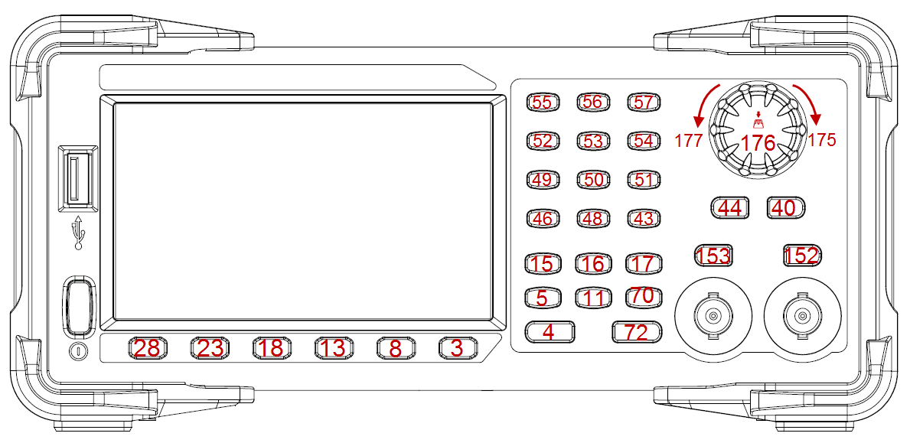
Keys and Indices on the SDG1000X Plus

EXAMPLE | VKEY VALUE,15,STATE,1  VKEY VALUE,KB_SWEEP,STATE,1

IP Command
DESCRIPTION | This command sets and gets the system IP address.
COMMAND SYNTAX | SYSTem:COMMunicate:LAN:IPADdress “<parameter1>.<parameter2>.<parameter3>.<parameter4>”  <parameter1>:={an integer value between 1 and 223}.  <parameter2>:={an integer value between 0 and 255}.  <parameter3>:={an integer value between 0 and 255}.  <parameter4>:={an integer value between 0 and 255}.
QUERY SYNTAX | SYSTem:COMMunicate:LAN:IPADdress?
EXAMPLES | Set IP address to 10.11.13.203:  SYST:COMM:LAN:IPAD “10.11.13.203”  Get the IP address:  SYST:COMM:LAN:IPAD?  Return:  “10.11.13.203”

Subnet Mask Command
DESCRIPTION | This command sets and gets the system subnet mask.
COMMAND SYNTAX | SYSTem:COMMunicate:LAN:SMASk “<parameter1>.<parameter2>.<parameter3>.<parameter4>”  <parameter1>:={an integer value between 0 and 255}.  <parameter2>:={an integer value between 0 and 255}.  <parameter3>:={an integer value between 0 and 255}.  <parameter4>:={an integer value between 0 and 255}.
QUERY SYNTAX | SYSTem:COMMunicate:LAN:SMASk?
EXAMPLES | Set the subnet mask to 255.0.0.0:  SYST:COMM:LAN:SMAS “255.0.0.0”  Get the subnet mask:  SYST:COMM:LAN:SMAS?  Return:  “255.0.0.0”

Gateway Command
DESCRIPTION | This command sets and gets the system gateway.
COMMAND SYNTAX | SYSTem:COMMunicate:LAN:GATeway “<parameter1>.<parameter2>.<parameter3>.<parameter4>”  <parameter1>:={an integer value between 0 and 223}.  <parameter2>:={an integer value between 0 and 255}.  <parameter3>:={an integer value between 0 and 255}.  <parameter4>:={an integer value between 0 and 255}.
QUERY SYNTAX | SYSTem:COMMunicate:LAN:GATeway?
EXAMPLES | Set Gateway to 10.11.13.5:  SYSTem:COMMunicate:LAN:GATeway “10.11.13.5”  Get gateway:  SYSTem:COMMunicate:LAN:GATeway?  Return:  “10.11.13.5”

Gpib Command
DESCRIPTION | This command sets and gets the port number for Gpib.
COMMAND SYNTAX | SYSTem:COMMunicate:GPIB:ADDRess <num>
QUERY SYNTAX | SYSTem:COMMunicate:GPIB:ADDRess?
EXAMPLES | Set the port number of Gpib to 19:  SYSTem:COMMunicate:GPIB:ADDRess 19  Get the port number of Gpib:  SYSTem:COMMunicate:GPIB:ADDRess?  Return:  19

File Operation Commands

MMEMory:DELete
DESCRIPTION | This command deletes the file.
COMMAND SYNTAX | MMEMory:DELete <parameter>  <parameter>:=”The path of the file”.
QUERY SYNTAX
RESPONSE FORMAT
EXAMPLE | Delete a file whose path is “Local/1000pts.bin”:  MMEMory:DELete “1000pts.bin”

MMEMory:RDIRectory
DESCRIPTION | This command deletes the directory.
COMMAND SYNTAX | MMEMory:RDIRectory <parameter>  <parameter>:=”The path of the directory”.
QUERY SYNTAX
EXAMPLE | Delete a directory whose path is “Local/test”:  MMEMory:RDIRectory “test”

MMEMory:MDIRectory
DESCRIPTION | This command creates a new directory.
COMMAND SYNTAX | MMEMory:MDIRectory <parameter>  <parameter>:=”The path of the directory”.
QUERY SYNTAX
EXAMPLE | Create a directory whose path is “Local/test”:  MMEMory:MDIRectory “test”

MMEMory:CATalog
DESCRIPTION | This command checks the files and the directories from the path or checks the file with specific type.
COMMAND SYNTAX | MMEMory:CATalog? <parameter>  <parameter>:=”The path of the directory”.  MMEMory:CATalog:DATA:ARBitrary? <parameter>  <parameter>:=”The path of the directory”.  MMEMory:CATalog:STATe:XMLanguage? <parameter>  <parameter>:=”The path of the directory”.
QUERY SYNTAX
RESPONSE FORMAT | remain space, used space  “File Name, File Type, File size”
EXAMPLE | Check the files and directories whose path is “Local/”:  MMEMory:CATalog? “Local”  Check the files with “.arb” or “.ARB” postfix whose path is “Local/”:  MMEMory:CATalog:DATA:ARBitrary? “”  Check the files with “.xml” or ”.XML” postfix whose path is “Local/”:  MMEMory:CATalog:STATe:XMLanguage? “”

MMEMory:COPY
DESCRIPTION | This command copies a file or a directory .
COMMAND SYNTAX | MMEMory:COPY <parameter>  <parameter>:= ”The path of the source”, “The path that the file is about to pasted to”.
QUERY SYNTAX
EXAMPLE | Copy the file whose path is ”Local/test/1000pts.bin” and paste to “Local/1000pts.bin”  MMEMory:COPY “1000pts.bin”,”1000pts.bin”  Copy the directory whose path is ”Local/src” and paste to “Local/copy/”  MMEMory:COPY “src”, ”copy”

MMEMory:MOVE
DESCRIPTION | This command movesthe file or the directory to a new location.
COMMAND SYNTAX | MMEMory:MOVE<parameter>  <parameter>:= ”The path of the source”, “The path of the source that is about to move to”.
QUERY SYNTAX
RESPONSE FORMAT
EXAMPLE | Move the file whose path is ”Local/test/1000pts.bin” to “Local/1000pts.bin”  MMEMory:MOVE “test/1000pts.bin”,”1000pts.bin”  Move the directory whose path is ”Local/src” to “Local/copy/paste”  MMEMory:MOVE “src”, ”copy/”

MMEMory:SAVE:XML
DESCRIPTION | This command saves an xml configuration file to the default path or specified path
COMMAND SYNTAX | MMEMory:SAVE:XML<parameter>  <parameter>:= {save path, including file name and suffix}.
QUERY SYNTAX
RESPONSE FORMAT
EXAMPLE | Save the test.xml file to the local  MMEMory:SAVE:XML "Local/test.xml" or  MMEMory:SAVE:XML "test.xml"

MMEMory:LOAD:XML
DESCRIPTION | Load an xml configuration file from the default path or the specified path
COMMAND SYNTAX | MMEMory:LOAD:XML<parameter>  <parameter>:= {path, including file name and suffix}.
QUERY SYNTAX
RESPONSE FORMAT
EXAMPLE | Load the test.xml file locally  MMEMory:SAVE:XML "Local/test.xml" or  MMEMory:SAVE:XML "test.xml"  Load the test.xml file from the USB flash drive  MMEMory:SAVE:XML "U-disk0/test.xml"

MMEMory:TRANsfer
DESCRIPTION | This command can send customized data to the specified bin file in the specified path
COMMAND SYNTAX | MMEMory:TRANsfer < parameter >,#{data}  <parameter>:= {path, including file name and suffix}.  {data}:= Length of data length+data length+binary data
QUERY SYNTAX
RESPONSE FORMAT
EXAMPLE | Send the data with the length of 1 and the length of 4 to the local wave1.bin  MMEMory:TRANsfer "Local/wave1.bin",#14ABCD  Send data with data length of 1 and data length of 4 to wave1.bin under USB flash disk  MMEMory:TRANsfer "U-disk0/wave1.bin",#14ABCD

Waveform format
This chapter gives a description of the waveform file format used by the signal source. Through these instructions, you can learn how to customize and edit the waveform file.
Note: The following table shows the waveform file formats supported in each model

Model / Format | SDG  800 | SDG  1000 | SDG  2000X | SDG  5000 | SDG  1000X | SDG  6000X/X-E | SDG  7000A
bin | y | y | y | y | y | y | y
csv |  |  | y |  | y | y | y
dat |  |  | y |  | y | y | y
mat |  |  |  |  |  |  | y
awg |  |  |  |  |  |  | y
hop |  |  |  |  |  |  | y
wav |  |  |  |  |  |  | y
arb |  |  |  |  |  |  | y

bin
The bin file content is binary, and the file content is the codeword value of each point (codeword range - 32768~32767). Manual editing is not supported. When the machine imports the file, it maintains the current amplitude, frequency and offset information, and directly converts each codeword value into voltage output.
Note: The following table shows the bin file length of each model

Model / param | SDG  800 | SDG  1000 | SDG  2000X | SDG  5000 | SDG  1000X | SDG  6000X-E | SDG  6000X | SDG  7000A
<length> | 32KB | 32KB | 4B~16MB | 32KB~ 1024KB | 4B~16MB | 4B~16MB | 4B~40MB | 4B~512M
codeword range | -32768~ 32767 | -32768~ 32767 | -32768~  32767 | -32768~ 32767 | -32768~  32767 | -32768~  32767 | -32768~  32767 | -32768~ 32767

csv/dat
The contents of the csv and dat files are text. The CSV file supported by SDG7000A is divided into header information and waveform data.
- The content of the csv header information contains the following four items. There can be more information items, but the following four items must be included, and more items will be ignored. One line for each item, ending with a newline character
Header information | Describe
amp, value | Amplitude of waveform
offset, value | Offset of waveform
frequency, value | Frequency of waveform
data length, value | Length of waveform

- Each group of segment data occupies one row. One of the following four strings can be used as the starting identifier (identifier occupies one line), which is placed before the wave data.
Starting identifier
Second, Volt
Xpos, value
Second, Volt
Second, Value

An example of csv format data is shown below：
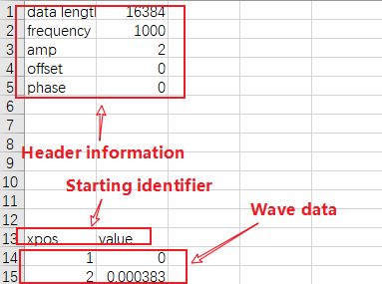

The header information is removed from the csv file, and only the data is retained, which is dat format.
An example of dat format data is shown below:
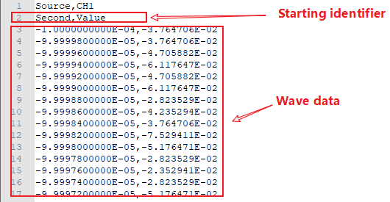

mat
The mat file is composed of a fixed 128-byte file header information (mat_head) and two data units
The file header is represented by the following structure, and only the endian_Indicator needs to be concerned, SDG7000A only supports IM mode:

typedef struct
{
char descriotive[116];
char data_offset[8];
uint16 version; //Version of the mat file
char endian_indicator[2]; // The value is IM or MI, indicates the size end mode
}cfg_mat_header_t;

There is a data header information (data_head, 88 bytes) at the beginning of each data unit, which is used to describe the number of bytes occupied by the data unit, data type, data block name and other information.
The data block header is represented by the following structure:
typedef struct
{
u32 data_type; // Value must be CFG_ MI_ MATRIX
u32 array_len;
u32 array_flag_data_type;
u32 array_flag_data_len;
u32 array_flag_data_1;
u32 array_flag_data_2;
u32 dimensions_array_data_type;
u32 dimensions_array_data_len;
u32 dimensions_array_data_1;
u32 dimensions_array_data_2;
u32 array_name_data_type;
u32 array_name_data_len;
char array_name_data[32]; // The oscilloscope export file is XX_Time or XX_data
u32 data_tag_data_type; // Type of waveform data
u32 data_tag_data_len; // Size of waveform data
}matlab_data_head_t;

XX_ data_ Type represents the data type, which corresponds to the following enumeration values:
typedef enum :
{
CFG_MI_INT8=1, //8 bit, signed
CFG_MI_UINT8, //8 bit, unsigned
CFG_MI_INT16, //16-bit, signed
CFG_MI_UINT16, //16-bit, unsigned
CFG_MI_INT32, //32-bit, signed
CFG_MI_UINT32, //32-bit, unsigned
CFG_MI_SINGLE, //IEEE 754 single format
CFG_MI_RESERVED1,
CFG_MI_DOUBLE, //=9, IEEE 754 double format
CFG_MI_RESERVED2,
CFG_MI_RESERVED3,
CFG_MI_INT64, //=12, 64-bit, signed
CFG_MI_UINT64, //64-bit, unsigned
CFG_MI_MATRIX, //MATLAB array
CFG_MI_COMPRESSED, //Compressed Data
CFG_MI_UTF8, //Unicode UTF-8 Encoded Character Data
CFG_MI_UTF16, //Unicode UTF-16 Encoded Character Data
CFG_MI_UTF32, //Unicode UTF-32 Encoded Character Data
}cfg_mat_data_type_t;

Mat files exported by matlab are in compressed format by default, and need to be saved in non-compressed format as follows. And only two data segment files are supported. Time data needs double, and waveform data needs single
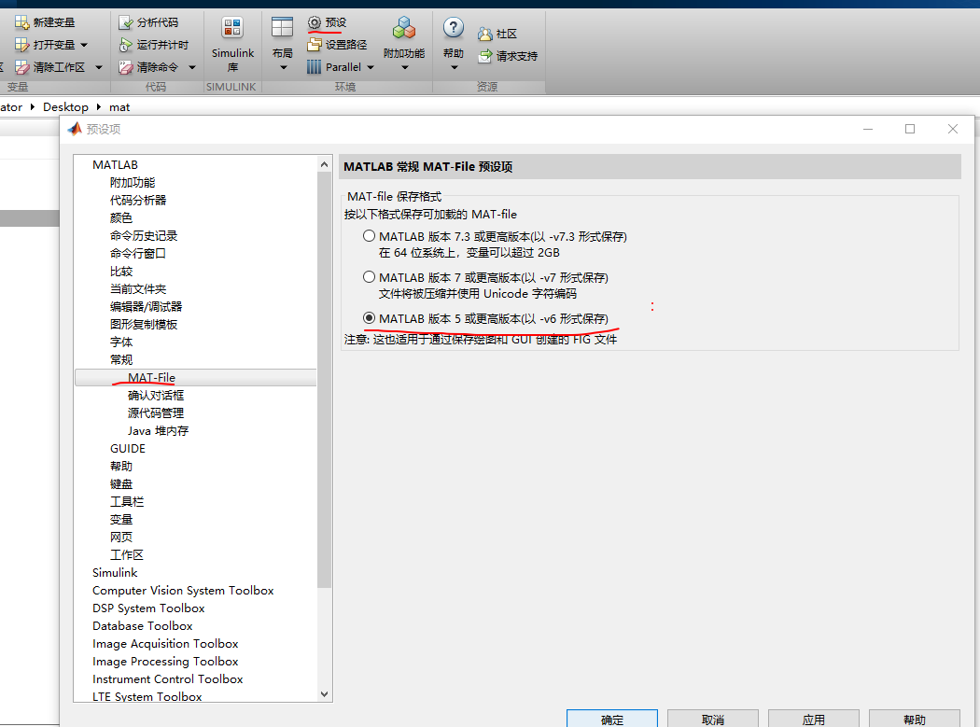

Programming Examples
This chapter gives some examples for the programmer. In these examples, you can see how to use VISA or sockets, in combination with the commands described above to control the generator. By following these examples, you can develop many more applications.

Examples of Using VISA

VC++ Example
Environment: Windows 7 32-bit, Visual Studio.
Description: Query the instrument information using "*IDN?" command over NI-VISA, with the access through USBTMC and TCP/IP separately.

Steps:
- Open Visual Studio and create a new VC++ win32 console project.

- Set the project environment to use the NI-VISA lib, there are two ways to specify NI-VISA, static or automatic:
  - Static:
Find the files visa.h, visatype.h, and visa32.lib in the NI-VISA installation path, copy them to the root path of the VC++ project, and add them to the project. In the project name.cpp file, add the following two lines:
#include "visa.h"
#pragma comment (lib,"visa32.lib")
  - Dynamic:
In "project---properties---c/c++---General---Additional Include Directories" set the value to the NI-VISA installation path (e.g. C:\Program Files\IVI Foundation\VISA\WinNT\include), as shown in the figure below:
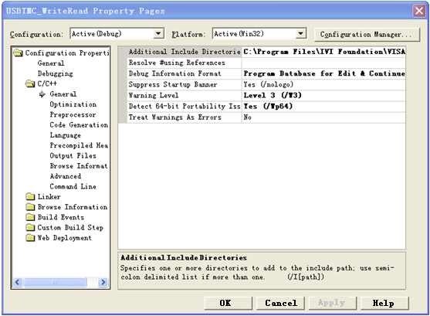

In " project---properties---Linker---General---Additional Library Directories " set the value to the NI-VISA installation path (e.g. C:\Program Files\IVI Foundation\VISA\WinNT\include), as shown in the figure below:
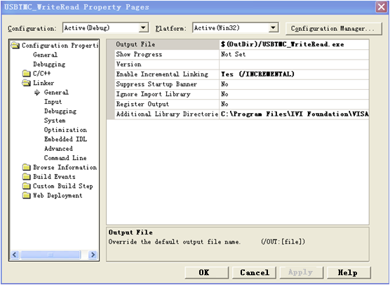
In "project---properties---Linker---Command Line---Additional" set the value to visa32.lib, as shown in the figure below:
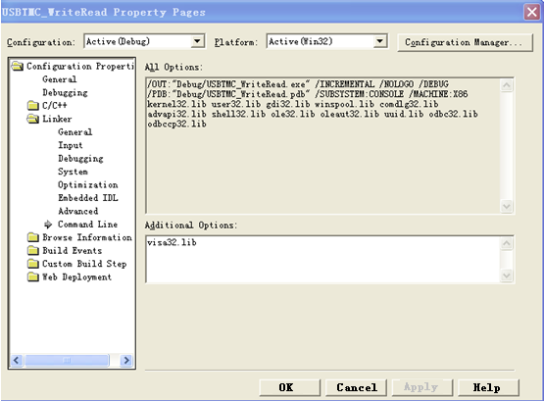
Include visa.h file in the projectname.cpp file:
#include <visa.h>

- Coding:
- USBTMC:

int Usbtmc_test()
{
/* This code demonstrates sending synchronous read & write commands */
/* to an USB Test & Measurement Class (USBTMC) instrument using */
/* NI-VISA */
/* The example writes the "*IDN?\n" string to all the USBTMC */
/* devices connected to the system and attempts to read back */
/* results using the write and read functions. */
/* The general flow of the code is */
/* Open Resource Manager */
/* Open VISA Session to an Instrument */
/* Write the Identification Query Using viPrintf */
/* Try to Read a Response With viScanf */
/* Close the VISA Session */
/***********************************************************/
ViSession defaultRM;
ViSession instr;
ViUInt32 numInstrs;
ViFindList findList;
ViStatus status;
char instrResourceString[VI_FIND_BUFLEN];
unsigned char buffer[100];
int i;
/** First we must call viOpenDefaultRM to get the manager
* handle. We will store this handle in defaultRM.*/
status=viOpenDefaultRM (&defaultRM);
if (status<VI_SUCCESS)
{
printf ("Could not open a session to the VISA Resource Manager!\n");
return status;
}
/* Find all the USB TMC VISA resources in our system and store the number of resources in the system in numInstrs. */
status = viFindRsrc (defaultRM, "USB?*INSTR", &findList, &numInstrs, instrResourceString);
if (status<VI_SUCCESS)
{
printf ("An error occurred while finding resources.\nPress 'Enter' to continue.");
fflush(stdin);
getchar();
viClose (defaultRM);
return status;
}
/** Now we will open VISA sessions to all USB TMC instruments.
* We must use the handle from viOpenDefaultRM and we must
* also use a string that indicates which instrument to open. This
* is called the instrument descriptor. The format for this string
* can be found in the function panel by right-clicking on the
* descriptor parameter. After opening a session to the
* device, we will get a handle to the instrument which we
* will use in later VISA functions. The AccessMode and Timeout
* parameters in this function are reserved for future
* functionality. These two parameters are given the value VI_NULL.*/
for (i=0; i<int(numInstrs); i++)
{
if (i> 0)
{
viFindNext (findList, instrResourceString);
}
status = viOpen (defaultRM, instrResourceString, VI_NULL, VI_NULL, &instr);
if (status<VI_SUCCESS)
{
printf ("Cannot open a session to the device %d.\n", i+1);
continue;
}
/* * At this point we now have a session open to the USB TMC instrument.
* We will now use the viPrintf function to send the device the string "*IDN?\n",
* asking for the device's identification. */
char * cmmand ="*IDN?\n";
status = viPrintf (instr, cmmand);
if (status<VI_SUCCESS)
{
printf ("Error writing to the device %d.\n", i+1);
status = viClose (instr);
continue;
}
/** Now we will attempt to read back a response from the device to
* the identification query that was sent. We will use the viScanf
* function to acquire the data.
* After the data has been read the response is displayed.*/
status = viScanf(instr, "%t", buffer);
if (status<VI_SUCCESS)
{
printf ("Error reading a response from the device %d.\n", i+1);
}
else
{
printf ("\nDevice %d: %s\n", i+1 , buffer);
}
status = viClose (instr);

}
/** Now we will close the session to the instrument using
* viClose. This operation frees all system resources. */
status = viClose (defaultRM);
printf("Press 'Enter' to exit.");
fflush(stdin);
getchar();
return 0;
}

int _tmain(int argc, _TCHAR* argv[])
{
Usbtmc_test();
return 0;
}

Run result:
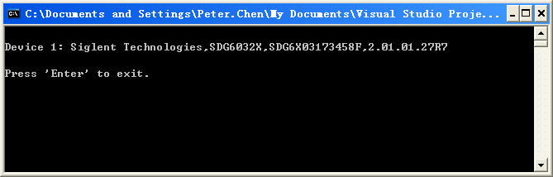

- TCP/IP:

int TCP_IP_Test(char *pIP)
{
char outputBuffer[VI_FIND_BUFLEN];
ViSession defaultRM, instr;
ViStatus status;
/* First we will need to open the default resource manager. */
status = viOpenDefaultRM (&defaultRM);
if (status<VI_SUCCESS)
{
printf("Could not open a session to the VISA Resource Manager!\n");
}
/* Now we will open a session via TCP/IP device */
char head[256] ="TCPIP0::";
char tail[] ="::INSTR";
strcat(head,pIP);
strcat(head,tail);
status = viOpen (defaultRM, head, VI_LOAD_CONFIG, VI_NULL, &instr);
if (status<VI_SUCCESS)
{
printf ("An error occurred opening the session\n");
viClose(defaultRM);
}
status = viPrintf(instr, "*idn?\n");
status = viScanf(instr, "%t", outputBuffer);
if (status<VI_SUCCESS)
{
printf ("viRead failed with error code: %x \n",status);
viClose(defaultRM);
}
else
{
printf ("\nMesseage read from device: %*s\n", 0,outputBuffer);
}
status = viClose (instr);
status = viClose (defaultRM);
printf("Press 'Enter' to exit.");
fflush(stdin);
getchar();
return 0;
}

int _tmain(int argc, _TCHAR* argv[])
{
printf("Please input IP address:");
char ip[256];
fflush(stdin);
gets(ip);
TCP_IP_Test(ip);
return 0;
}

Run result:
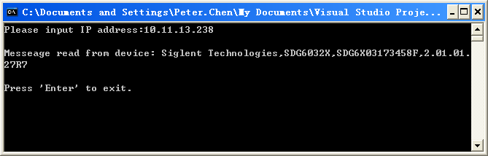

VB Example
Environment: Windows 7 32-bit, Microsoft Visual Basic 6.0
Description: Query the instrument information using the “*IDN?" command over NI-VISA, via USBTMC and TCP/IP separately.

Steps:
- Open Visual Basic, and build a standard application program project.
- Set the project environment to use the NI-VISA lib: Click the Existing tab of Project>>Add Existing Item, search the visa32.bas file in the “include” folder under the NI-VISA installation path and add the file, as shown in the figure below:

- Coding:
  - USBTMC:
Private Function Usbtmc_test() As Long
‘ This code demonstrates sending synchronous read & write commands
‘ to an USB Test & Measurement Class (USBTMC) instrument using
‘ NI-VISA
‘ The example writes the “*IDN?\n” string to all the USBTMC
‘ devices connected to the system and attempts to read back
‘ results using the write and read functions.
‘ The general flow of the code is
‘ Open Resource Manager
‘ Open VISA Session to an Instrument
‘ Write the Identification Query Using viWrite
‘ Try to Read a Response With viRead
‘ Close the VISA Session
Const MAX_CNT = 200

Dim defaultRM As Long
Dim instrsesn As Long
Dim numlnstrs As Long
Dim findList As Long
Dim retCount As Long
Dim status As Long
Dim instrResourceString As String * VI_FIND_BUFLEN
Dim Buffer As String * MAX_CNT
Dim I As Integer

‘' First we must call viOpenDefaultRM to get the manager
‘' handle. We will store this handle in defaultRM.
status = viOpenDefaultRM(defaultRM)
If (status < VI_SUCCESS) Then
resultTxt.Text =“"Could not open a session to the VISA Resource Manager”"
Usbtmc_test = status
Exit Function
End If

‘' Find all the USB TMC VISA resources in our system and store the
‘' number of resources in the system in numInstrs.
status = viFindRsrc(defaultRM,“"USB?*INST”", findList, numlnstrs, instrResourceString)
If (status < VI_SUCCESS) Then
resultTxt.Text =“"An error occurred while finding resources”"
viClose(defaultRM)
Usbtmc_test = status
Exit Function
End If

‘' Now we will open VISA sessions to all USB TMC instruments.
‘' We must use the handle from viOpenDefaultRM and we must
‘' also use a string that indicates which instrument to open. This
‘' is called the instrument descriptor. The format for this string
‘' can be found in the function panel by right-clicking on the
‘' descriptor parameter. After opening a session to the
‘' device, we will get a handle to the instrument which we
‘' will use in later VISA functions. The AccessMode and Timeout
‘' parameters in this function are reserved for future
‘' functionality. These two parameters are given the value VI_NULL.
For i = 0 To numInstrs
If (i > 0) Then
status = viFindNext(findList, instrResourceString)
End If
status = viOpen(defaultRM, instrResourceString, VI_NULL, VI_NULL, instrsesn)
If (status < VI_SUCCESS) Then
resultTxt.Text =“"Cannot open a session to the device“" + CStr(i + 1)
GoTo NextFind
End If

‘' At this point we now have a session open to the USB TMC instrument.
‘' We will now use the viWrite function to send the device the string“"*IDN”",
‘' asking for the devic’'s identification.
status = viWrite(instrsesn,“"*IDN”", 5, retCount)
If (status < VI_SUCCESS) Then
resultTxt.Text =“"Error writing to the device”"
status = viClose(instrsesn)
GoTo NextFind
End If
‘' Now we will attempt to read back a response from the device to
‘' the identification query that was sent. We will use the viRead
‘' function to acquire the data.
‘' After the data has been read the response is displayed.
status = viRead(instrsesn, Buffer, MAX_CNT, retCount)
If (status < VI_SUCCESS) Then
resultTxt.Text =“"Error reading a response from the device”" + CStr(i + 1)
Else
resultTxt.Text =“"Read from device:“" + CStr(i + 1) +“"“" + Buffer
End If
status = viClose(instrsesn)
Next i

‘' Now we will close the session to the instrument using
‘' viClose. This operation frees all system resources.
status = viClose(defaultRM)
Usbtmc_test = 0
End Function

  - TCP/IP:
Private Function TCP_IP_Test(ByVal ip As String) As Long
Dim outputBuffer As String * VI_FIND_BUFLEN
Dim defaultRM As Long
Dim instrsesn As Long
Dim status As Long
Dim count As Long

‘' First we will need to open the default resource manager.
status = viOpenDefaultRM(defaultRM)
If (status < VI_SUCCESS) Then
resultTxt.Text =“"Could not open a session to the VISA Resource Manager”"
TCP_IP_Test = status
Exit Function
End If

‘' Now we will open a session via TCP/IP device
status = viOpen(defaultRM,“"TCPIP0:”" + ip +“"::INST”", VI_LOAD_CONFIG, VI_NULL, instrsesn)
If (status < VI_SUCCESS) Then
resultTxt.Text =“"An error occurred opening the sessio”"
viClose(defaultRM)
TCP_IP_Test = status
Exit Function
End If

status = viWrite(instrsesn,“"*IDN”", 5, count)
If (status < VI_SUCCESS) Then
resultTxt.Text =“"Error writing to the device”"
End If
status = viRead(instrsesn, outputBuffer, VI_FIND_BUFLEN, count)
If (status < VI_SUCCESS) Then
resultTxt.Text =“"Error reading a response from the device”" + CStr(i + 1)
Else
resultTxt.Text =“"read from device”" + outputBuffer
End If
status = viClose(instrsesn)
status = viClose(defaultRM)
TCP_IP_Test = 0
End Function

  - Button control code:
Private Sub exitBtn_Click()
End
End Sub
Private Sub tcpipBtn_Click()
Dim stat As Long
stat = TCP_IP_Test(ipTxt.Text)
If (stat < VI_SUCCESS) Then
resultTxt.Text = Hex(stat)
End If
End Sub
Private Sub usbBtn_Click()
Dim stat As Long
stat = Usbtmc_test
If (stat < VI_SUCCESS) Then
resultTxt.Text = Hex(stat)
End If
End Sub

Run result:
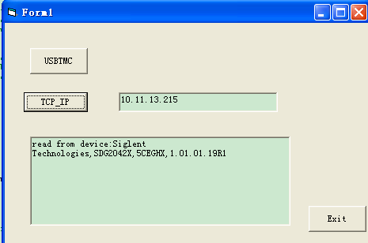

MATLAB Example
Environment: Windows 7 32-bit, MATLAB R2013a
Description: Query the instrument information using the "*IDN?" command over NI-VISA, with the access through USBTMC and TCP/IP separately.

Steps:
- Open MATLAB, and modify the current directory. In this demo, the current directory is modified to "D:\USBTMC_TCPIP_Demo".

- Click File>>New>>Script in the Matlab interface to create an empty M file.

- Coding:
  - USBTMC:
function USBTMC_test()
% This code demonstrates sending synchronous read & write commands
% to an USB Test & Measurement Class (USBTMC) instrument using
% NI-VISA

%Create a VISA-USB object connected to a USB instrument
vu = visa('ni','USB0::0xF4ED::0xEE3A::sdg2000x::INSTR');

%Open the VISA object created
fopen(vu);

%Send the string "*IDN?",asking for the device's identification.
fprintf(vu,'*IDN?');

%Request the data
outputbuffer = fscanf(vu);
disp(outputbuffer);

%Close the VISA object
fclose(vu);
delete(vu);
clear vu;

end

Run result:
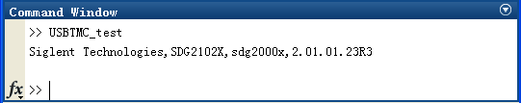

  - TCP/IP:
Write a function TCP_IP_Test:
function TCP_IP_test()
% This code demonstrates sending synchronous read & write commands
% to a TCP/IP instrument using NI-VISA

%Create a VISA-TCPIP object connected to an instrument
%configured with IP address.
vt = visa('ni',['TCPIP0::','10.11.13.32','::INSTR']);

%Open the VISA object created
fopen(vt);

%Send the string "*IDN?",asking for the device's identification.
fprintf(vt,'*IDN?');

%Request the data
outputbuffer = fscanf(vt);
disp(outputbuffer);

%Close the VISA object
fclose(vt);
delete(vt);
clear vt;

end

Run result:
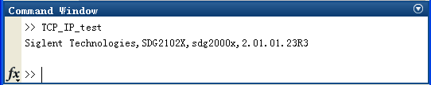

LabVIEW Example
Environment: Windows 7 32-bit, LabVIEW 2011
Description: Query the instrument information using the “*IDN?" command over NI-VISA, with the access through USBTMC and TCP/IP separately.

Steps:
- Open LabVIEW, and create a VI file.
- Add controls. Right-click in the Front Panel interface, select and add VISA resource name, error in, error out and some indicators from the Controls column.
- Open the Block Diagram interface. Right-click on the VISA resource name, select and add the following functions from VISA Palette from the pop-up menu: VISA Write, VISA Read, VISA Open, and VISA Close.
- The connection is as shown in the figure below:
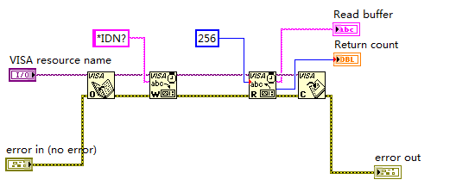

- Select the device resource from the VISA Resource Name list box and run the program.
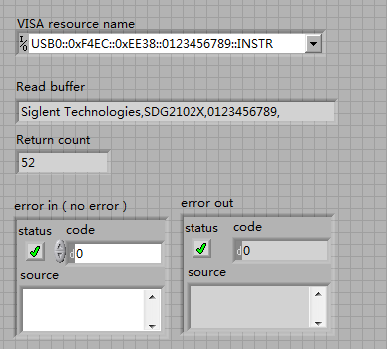

In this example, the VI opens a VISA session to a USBTMC device, writes a "*IDN?" command to the device, and reads back the response. After all communication is complete, the VI closes the VISA session.

- Communicating with the device via TCP/IP is similar to USBTMC. But you need to change VISA Write and VISA Read Function to Synchronous I/O. The LabVIEW default is asynchronous I/O. Right-click the node and select Synchronous I/O Mod>>Synchronous from the shortcut menu to write or read data synchronously.

- The connection is as shown in the figure below:
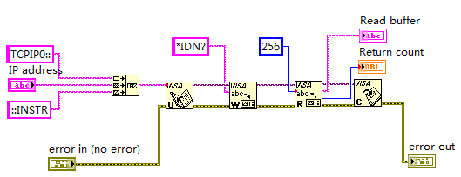

- Input the IP address and run the program.

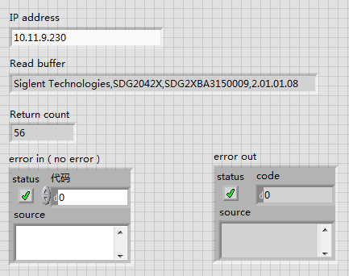

Python2 Example
Environment: Python2.7, PyVISA 1.4
(Please install PyVISA after installing Python2.7. Please refer to https://pyvisa.readthedocs.io/en/stable/getting.html for the PyVISA installation guide.

Description: Use Python script to build an 8-point 16-bit arbitrary waveform (0x1000, 0x2000, 0x3000, 0x4000, 0x5000, 0x6000, 0x7000, 0x7fff) and save the waveform data in "wave1.bin", then download it to the instrument, finally read it back from the instrument and save it as "wave2.bin".
Below is the code of the script:

#!/usr/bin/env python2.7
# -*- coding: utf-8 -*-

import visa
import time
import binascii

#USB resource of Device
device_resource = "USB0::0xF4EC::0x1101::#15::INSTR"

#Little endian, 16-bit 2's complement
wave_points = [0x0010, 0x0020, 0x0030, 0x0040, 0x0050, 0x0060, 0x0070, 0xff7f]

def create_wave_file():
"""create a file"""
f = open("wave1.bin", "wb")
for a in wave_points:
b = hex(a)
b = b[2:]
len_b = len(b)
if (0 == len_b):
b = '0000'
elif (1 == len_b):
b = '000' + b
elif (2 == len_b):
b = '00' + b
elif (3 == len_b):
b = '0' + b
c = binascii.a2b_hex(b) #Hexadecimal integer to ASCii encoded string
f.write(c)
f.close()

def send_wawe_data(dev):
"""send wave1.bin to the device"""
f = open("wave1.bin", "rb") #wave1.bin is the waveform to be sent
data = f.read()
print 'write bytes:',len(data)
dev.write("C1:WVDT WVNM,wave1,FREQ,2000.0,AMPL,4.0,OFST,0.0,PHASE,0.0,WAVEDATA,%s" % (data)) #"X" series (SDG1000X/SDG2000X/SDG6000X/X-E)
dev.write("C1:ARWV NAME,wave1")
f.close()

def get_wave_data(dev):
"""get wave from the devide"""
f = open("wave2.bin", "wb") #save the waveform as wave2.bin
dev.write("WVDT? user,wave1") #"X" series (SDG1000X/SDG2000X/SDG6000X/X-E)
time.sleep(1)
data = dev.read()
data_pos = data.find("WAVEDATA,") + len("WAVEDATA,")
print data[0:data_pos]
wave_data = data[data_pos:]
print 'read bytes:',len(wave_data)
f.write(wave_data)
f.close()

if __name__ == '__main__':
""""""
device = visa.instrument(device_resource, timeout=5000, chunk_size = 40*1024)
create_wave_file()
send_wawe_data(device)
get_wave_data(device)

Output waveform:
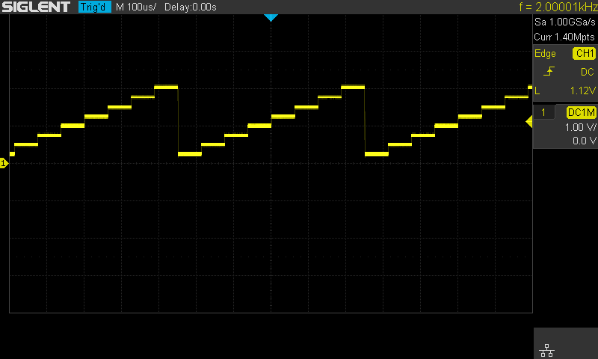

Python3 Example
Environment: Python3.6.5, PyVISA 1.9

#!/usr/bin/env python3.6.5
# -*- coding: utf-8 -*-

import visa
import time
import binascii

#USB resource of Device
device_resource = 'USB0::0xF4EC::0x1102::SDG7ABAQ5R0010::INSTR'
#Little endian, 16-bit2's complement
wave_points = [0x0080, 0x0070, 0x0060, 0x0040, 0x0050, 0x0060, 0x0070, 0xff7f,0x0050]

def create_wave_file():
"""create a file"""
f = open("wave1.bin", "wb")
for a in wave_points:
b = hex(a)
b = b[2:]
len_b = len(b)
if (0 == len_b):
b = '0000'
elif (1 == len_b):
b = '000' + b
elif (2 == len_b):
b = '00' + b
elif (3 == len_b):
b = '0' + b
c = binascii.a2b_hex(b) #Hexadecimal integer to ASCii encoded string
f.write(c)
f.close()

def send_wawe_data(dev):
"""send wave1.bin to the device"""
f = open("wave1.bin", "rb") #wave1.bin is the waveform to be sent
data = f.read()
print ('write bytes:%s'%len(data))
dev.write("C1:WVDT WVNM,wave1,FREQ,2000.0,AMPL,4.0,OFST,0.0,PHASE,0.0,WAVEDATA,%s" % (data))
#"X" series (SDG1000X/SDG2000X/SDG6000X/X-E)
dev.write("C1:ARWV NAME,wave1")
f.close()

def get_wave_data(dev):
"""get wave from the devide"""
f = open("wave2.bin", "wb") #save the waveform as wave2.bin
dev.write("WVDT? user,wave1") #"X" series (SDG1000X/SDG2000X/SDG6000X/X-E)
time.sleep(1)
data = dev.read()
data_pos = data.find("WAVEDATA,") + len("WAVEDATA,")
print (data[0:data_pos])
wave_data = data[data_pos:]
print ('read bytes:%s'%len(wave_data))
f.write(wave_data)
f.close()

if __name__ == '__main__':
""""""
rm=visa.ResourceManager()
device =rm.open_resource(device_resource, timeout=50000, chunk_size = 24*1024*1024)
create_wave_file()
send_wawe_data(device)
#get_wave_data(device)

Python3 Example (Digital)
Environment: Python3.6.5, PyVISA 1.9

#!/usr/bin/env python3
# -*- coding: utf-8 -*-

import pyvisa as visa
import time
import binascii

# resource of Device
device_resource = 'USB0::0xF4EC::0x1102::SDG7ACBC5M0005::INSTR'

d7 = '000011110000' # Data stream of ch7 in digital
d6 = '101010101010' # Data stream of ch6 in digital
d5 = '010101010101' # Data stream of ch5 in digital
d4 = '110011001100' # Data stream of ch4 in digital
d3 = '000000111111' # Data stream of ch3 in digital
d2 = '111000111000' # Data stream of ch2 in digital
d1 = '001100110011' # Data stream of ch1 in digital
d0 = '110011001100' # Data stream of ch0 in digital
other = '00000000' # The last 8ch data is 0
wave_points = []
for i7, i6, i5, i4, i3, i2, i1, i0 in zip(d7, d6, d5, d4, d3, d2, d1, d0):
a = i7 + i6 + i5 + i4 + i3 + i2 + i1 + i0 + other
wave_points.append(int(a, 2))

def create_wave_file():
"""create a file"""
f = open("wave1.bin", "wb")
for a in wave_points:
b = hex(a)
b = b[2:]
len_b = len(b)
if (0 == len_b):
b = '0000'
elif (1 == len_b):
b = '000' + b
elif (2 == len_b):
b = '00' + b
elif (3 == len_b):
b = '0' + b
c = binascii.unhexlify(b) # Hexadecimal integer to ASCii encoded string
f.write(c)
f.close()

def send_wave_data(dev):
"""send wave1.bin to the device"""
f = open("wave1.bin", "rb") # wave1.bin is the waveform to be sent
data = f.read().decode("latin1")
print('write class:', type(data))
print('write bytes:', len(data))
dev.write_termination = ''
dev.write("DIG:WVDT WVNM,digital, WAVEDATA,%s" % (data), encoding='latin1')
f.close()
return data

if __name__ == '__main__':
""""""
rm = visa.ResourceManager()
device = rm.open_resource(device_resource, timeout=50000, chunk_size=24 * 1024 * 1024)
create_wave_file()
send = send_wave_data(device)
print('Done')

Examples of Using Sockets

Python Example
Python has a low-level networking module that provides access to the socket interface. Python scripts can be written for sockets to do a variety of tests and measurement tasks.
Environment: Windows 7 32-bit, Python v2.7.5
Description: Open a socket, send a query, and repeat this loop 10 times, finally close the socket. Note that SCPI command strings must be terminated with a “\n” (new line) character in programming.

Below is the code of the script:
#!/usr/bin/env python
#-*- coding:utf-8 –*-
#-----------------------------------------------------------------------------
# The short script is an example that opens a socket, sends a query,
# print the return message and closes the socket.
#-----------------------------------------------------------------------------

import socket # for sockets
import sys # for exit
import time # for sleep

#-----------------------------------------------------------------------------

remote_ip = "10.11.13.40" # should match the instrument’s IP address
port = 5025 # the port number of the instrument service
count = 0

def SocketConnect():
try:
#create an AF_INET, STREAM socket (TCP)
s = socket.socket(socket.AF_INET, socket.SOCK_STREAM)
except socket.error:
print ('Failed to create socket.')
sys.exit();
try:
#Connect to remote server
s.connect((remote_ip , port))
except socket.error:
print ('failed to connect to ip ' + remote_ip)
return s

def SocketQuery(Sock, cmd):
try :
#Send cmd string
Sock.sendall(cmd)
time.sleep(1)
except socket.error:
#Send failed
print ('Send failed')
sys.exit()
reply = Sock.recv(4096)
return reply

def SocketClose(Sock):
#close the socket
Sock.close()
time.sleep(.300)

def main():
global remote_ip
global port
global count

# Body: send the SCPI commands “*IDN?” 10 times and print the return message
s = SocketConnect()
for i in range(10):
qStr = SocketQuery(s, b'*IDN?\n')
print (str(count) + ":: " + str(qStr))
count = count + 1
SocketClose(s)
input('Press "Enter" to exit')

if __name__ == '__main__':
proc = main()

Run result:
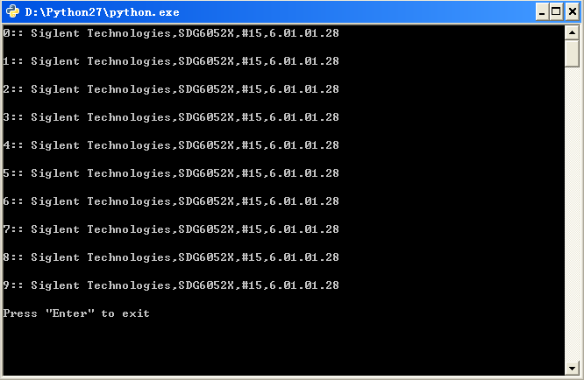

Index
*IDN
*OPC
*RST

A
ARWV ArbWaVe

B
BSWV BaSic_WaVe
BTWV BursTWaVe
BUZZ BUZZer

C
CASCADE
CHDR Comm_HeaDeR
COUP COUPling
CMBN CoMBiNe

F
FCNT FreqCouNTer

H
HARM HARMonic

I
IQ:CENT IQ:CENTerfreq
IQ:SAMP IQ:SAMPlerate
IQ:SYMB IQ:SYMBolrate
IQ:AMPL IQ:AMPLitude
IQ:IQAD:GAIN IQ:IQADjustment:GAIN
IQ:IQAD:IOFFset IQ:IQADjustment:IOFFset
IQ:IQAD:QOFFset IQ:IQADjustment:QOFFset
IQ:IQAD:QSK IQ:IQADjustment:QSKew
IQ:TRIG:SOUR IQ:TRIGger:SOURce
IQ:WAVE:BUIL IQ:WAVEload:BUILtin
IQ:WAVE:USER IQ:WAVEload:USERstored
IQ:FrequencySampling IQ:FrequencySampling
IVNT INVERT

L
LAGG LAnGuaGe

M
MDWV MoDulateWaVe
MODE MODE

N
NBFM NumBer_ForMat

O
OUTP OUTPut

P
PACP ParaCoPy

R
ROSC ROSCillator

S
SCFG Sys_CFG
SCSV SCreen_SaVe
SWWV SweepWaVe
SYNC SYNC
STL StoreList
SYST:COMM:LAN:IPAD SYSTem:COMMunicate:LAN:IPADdress
SYST:COMM:LAN:SMAS SYSTem:COMMunicate:LAN:SMASk
SYST:COMM :LAN:GAT SYSTem:COMMunicate:LAN:GATeway
SRATE SampleRATE

W
WVDT WVDT

V
VOLTPRT VOLTPRT
VKEY VirtualKEY

About SIGLENT
SIGLENT is an international high-tech company, concentrating on R&D, sales, production and services of electronic test & measurement instruments.

SIGLENT first began developing digital oscilloscopes independently in 2002. After more than a decade of continuous development, SIGLENT has extended its product line to include digital oscilloscopes, isolated handheld oscilloscopes, function/arbitrary waveform generators, RF/MW signal generators, spectrum analyzers, vector network analyzers, digital multimeters, DC power supplies, electronic loads and other general purpose test instrumentation. Since its first oscilloscope was launched in 2005, SIGLENT has become the fastest growing manufacturer of digital oscilloscopes. We firmly believe that today SIGLENT is the best value in electronic test & measurement.
Headquarters:
SIGLENT Technologies Co., Ltd
Add: Bldg No.4 & No.5, Antongda Industrial Zone, 3rd Liuxian Road, Bao'an District, Shenzhen, 518101, China
Tel: + 86 755 3688 7876
Fax: + 86 755 3359 1582
Email: sales@siglent.com
Website: int.siglent.com

North America:
SIGLENT Technologies America, Inc
6557 Cochran Rd Solon, Ohio 44139
Tel: 440-398-5800
Toll Free: 877-515-5551
Fax: 440-399-1211
Email: info@siglentna.com
Website: www.siglentna.com

Europe:
SIGLENT Technologies Germany GmbH
Add: Staetzlinger Str. 70
86165 Augsburg, Germany
Tel: +49(0)-821-666 0 111 0
Fax: +49(0)-821-666 0 111 22
Email: info-eu@siglent.com
Website: www.siglenteu.com

